Joseph Henry’s House and Campus Plan
Ezra Y. S. Tjung, Daniel Kaufmann, Michael G. Littman
Department of Mechanical and Aerospace Engineering Engineering Quadrangle, Princeton University Princeton, NJ 08544 email contact: mlittman@princeton.edu

Abstract
Joseph Henry is often credited with the design of the Joseph Henry House, a registered National Historic Landmark on the Princeton University Campus. Joseph Henry was Professor of Natural Philosophy and Mathematics at Princeton College at the beginning of the 19th century. He also taught Architecture and Geology, and had worked earlier in the State of New York as a surveyor. In 1846, Prof. Henry moved to Washington DC to assume leadership of the Smithsonian as its first Secretary. We set out to verify that Joseph Henry was responsible for the design of the House that bears his name, and found to our surprise that it is unlikely that he designed it. Our conclusion is based on a review of many financial documents and other records of the College, published and unpublished papers and letters of Joseph Henry, and a diary of a key member of the College Building Committee. We have established that Ezekial Howell, a local mason, was the principal builder of the House. We have also determined that Charles Steadman, a local carpenter and builder, was responsible for drawings of the House. While it is possible that Steadman as draftsman was following Henry’s specifications, we find that this is unlikely given that the House constructed in 1838 is so similar to others built by Steadman in the Princeton area. Prof. Henry did make his own drawing of a house and submitted it to the Building Committee, but his design is not like the design of the house that was built. That withstanding, Joseph Henry did select the location of the house as well as that of several other early buildings as part of his influential Campus Plan. A previously unknown freehand draft of the Campus Plan was discovered at the Smithsonian indicating location of several unrealized buildings.

Introduction
Built in 1838 and named a National Historic Landmark in 1965, the Joseph Henry House is one of the earlier structures at the College of New Jersey (now Princeton University) [1 – 7]. The House has been moved three times – perhaps a record – but its original location was close to the College’s two original buildings, Nassau Hall and the President’s House. Both of these structures still exist. Princeton College and its grounds are shown in the 1764 engraving by Henry Dawkins in Figure 1 [8]. Today we would describe this engraving as showing the entire College campus. ‘Campus’ is the latin word for ‘field’, and its first use to describe college grounds was in reference to the patch of land in front of Nassau Hall [9].
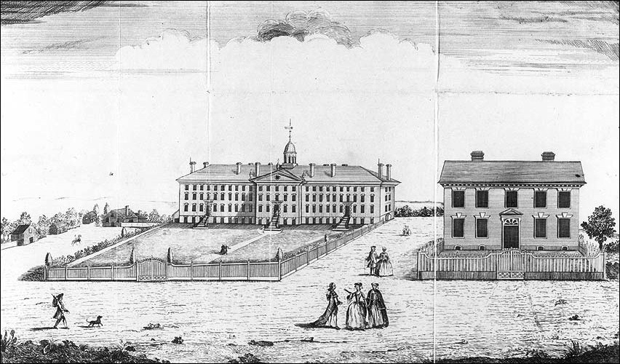
Figure 1 – College of New Jersey – Nassau Hall and the President’s House - 1764
Joseph Henry proposed a plan for development of Princeton College in 1836. The plan was formally accepted by action of the Board of Trustees [10]. Henry’s plan included a new location for his home, as well as placement of several proposed buildings. His plan called for a building arrangement that was symmetrical about Nassau Hall [11]. Joseph Henry was hired in 1832 by Vice President John Maclean Jr. to teach Natural philosophy and Mathematics. He served as Princeton faculty member for fourteen years in a time when the entire faculty (tutors and professors) numbered about fifteen [3]. Besides Natural Philosophy and Mathematics, he also taught courses in Geology, and Architecture. He moved to Washington DC in 1846 to lead the Smithsonian Institution as its first Secretary.
The Joseph Henry House is a brick dwelling in the Federal style with a Greek Rival Portico. It has been suggested by many sources that Prof. Henry designed it himself. Henry and his family members were its first occupants when the construction was completed in mid-September 1838. A study of the House and documents relating to its origins, reveal interesting facts but no evidence that Joseph Henry designed it. Henry did present a drawing to the Trustees in January 1837 for a house [12, 13], but this drawing bears little resemblance to the house that was built [1, 14]. The brick house as built, however, is very similar to many wooden houses in the Princeton area constructed by carpenter and builder Charles Steadman [1], suggesting that perhaps he may have been involved in the design.

Early Days in Princeton
Prof. Henry is best known for his many fundamental contributions in the then-new field of electromagnetism and especially for his discovery of self-inductance [15]. Electromagnetic induction, usually credited to Michael Faraday, is the creation of a voltage between ends of a loop of wire when exposed to a changing magnetic field. The term of art in the 19th century for this phenomenon was magneto-electricity, that is, electricity from magnetism. Electromagnetic induction often involves two coils in proximity – one to produce a changing magnetic field and another to convert the changing magnetic field into a voltage. This property of electricity and magnetism is the basis of the electromagnetic transformer. Joseph Henry discovered that a voltage can be produced in the same coil used to produce the magnetic field – this phenomenon is known as self-inductance and it is the basis of an effect commonly observed and known as ‘back voltage’ or ‘back EMF’. In the standard system of units used internationally (Le Systeme International d’Unites or SI), the unit of electrical inductance is the henry, named after him [16]. Henry is also known for constructing the strongest electromagnets of his era [17], and for discovering how to apply electromagnetism for the transmission of information and power. He demonstrated a sounding-type telegraph before Samuel Morse [18] and he constructed the first practical electromagnetic engine, which was a precursor to the modern electric motor and the modern electromagnetic relay [19].
Henry moved to Princeton in 1832 from the Albany Academy where he taught Mathematics and Natural Philosophy for eight years [20]. Upon arriving in Princeton, Joseph Henry was provided use of a house that stood immediately to the west of Nassau Hall. At that time there were three professor’s houses; one occupied by the Prof. of Chemistry and Vice President John Maclean Jr.; another by Prof. of Mathematics Albert Dod; and the third by Prof. Henry and his family. Henry’s assigned home had been used previously by Prof. Henry Vethake, the faculty member that he was replacing [6, 7]. Figure 2 is a map drawn by Prof. Henry for his brother, James Henry, in an 1833 letter [21]. Henry’s house, labeled “our house” in Figure 2, can be seen also in Figure 3, a circa 1825 drawing of the front campus by an unknown artist [22]. Henry’s original house is located immediately to the right of Nassau Hall in Figure 3 and it faces the street (Nassau Street). Figure 4 shows a cropped image of this house that exhibits 5 bays in a Federal style. The house to the left of Nassau Hall in Figure 3 (labeled as the “steward’s house” in Figure 2) is visually similar to Henry’s house.

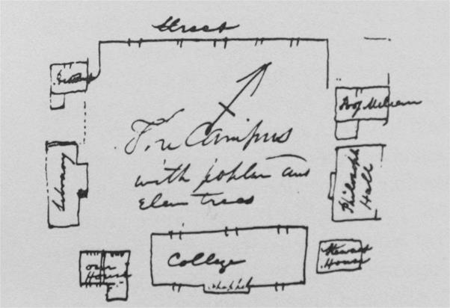
Figure 2 - Henry's map of the Front Campus with Poplar and Elm Trees - 1833

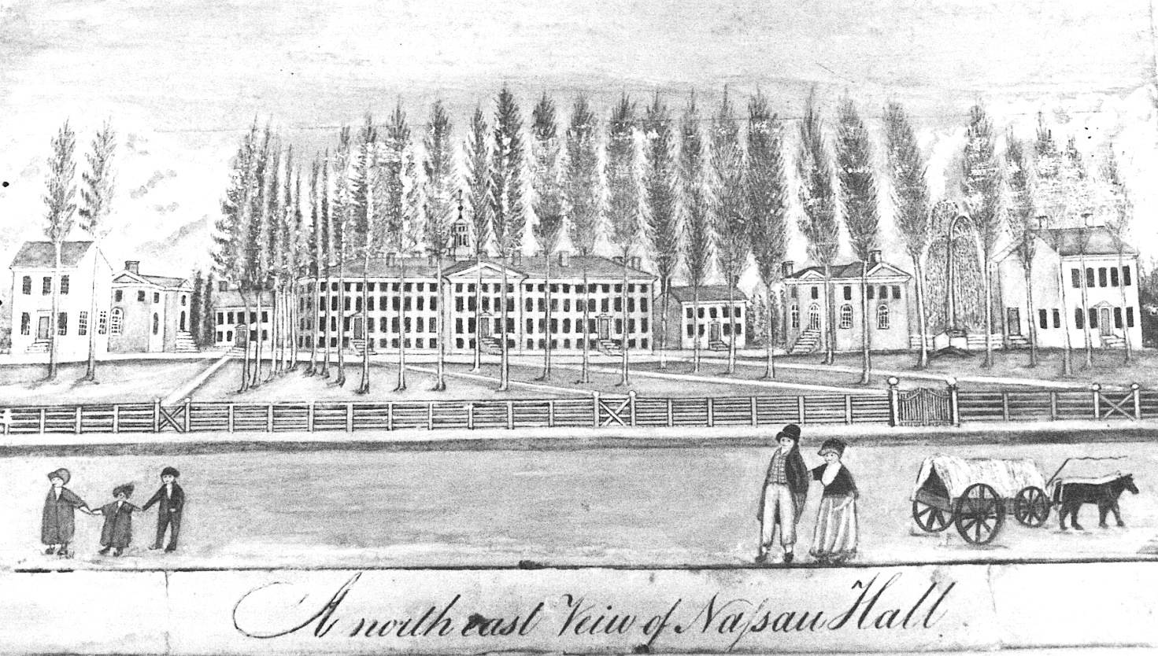
Figure 3 – Drawing of Princeton’s Front Campus as seen from Street - circa 1825

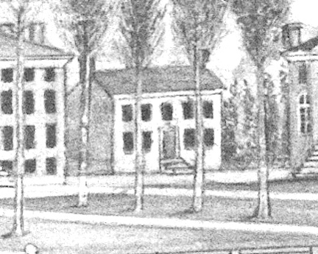
Figure 4 – Cropped view of the Professor’s House occupied by Joseph Henry until 1837

On September 29, 1835, the Board of Trustees decided to expand Henry’s house [23].
“Resolved that an addition be made to the house of Professor Henry, by erecting a wing on the southwest end of the house, which shall contain four comfortable rooms of such materials, and on such plan as the building committee may judge proper, and that the funds necessary for completing this addition be procured in the same manner, as prescribed in the second resolution [that is, to get loan from a bank].”

Henry’s Campus Plan
Besides being the Professor of Natural Philosophy and Mathematics, Henry was also a member of Whig Society. The Whig Society was one of two debating clubs at the College - the other was The Cliosophic Society. Both debating societies are still active at Princeton University. In a circular printed in 1836 [11], an appeal for funds was made to build a new hall for the Society. Henry drew a plan for the campus that was included in this document. In the letter to members, it is written,
"The erection of the new Halls is intimately connected with the improvement of the College grounds, as these edifices can be so placed in reference to the buildings now erected as to form with the latter a convenient and beautiful architectural arrangement. The plan of the disposition of the whole will readily be understood by a reference to the annexed Map."
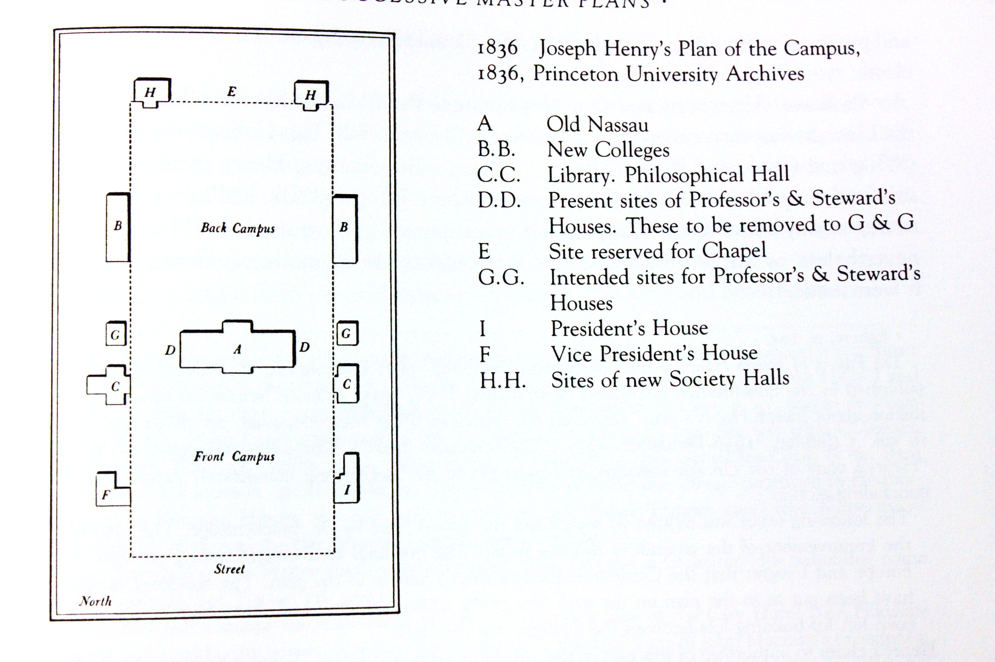 Figure 5 - Henry's Campus Plan of 1836

At the time of this letter, buildings A (Nassau Hall), B-left, C-left, C-right, F, and I were already present. Building B-right (today known as West College) was under construction. Buildings G-left, G-right, H-left, and H-right did not yet exist. Two existing structures, D-left (“steward’s house”) and D-right (“our house”), were proposed for relocation to G-left and G-right. Prior to the construction of the Halls, the debating societies met in the C-right (Library). We discovered an earlier freehand draft of the printed Campus Plan in the Smithsonian Institution Archives along with other Joseph Henry documents [24]. This freehand version of the Figure 5 plan is shown in Figure 6. Henry’s wished to continue the strict symmetry of the Campus by pairing new buildings on each side of Nassau Hall at a respectful distance. At the rear of the campus, Whig Hall is paired with Clio Hall. East-West symmetry was already present, but Henry added to the concept of a back campus delineated with the proposed Halls. Henry proposed also that his house be set in alignment with the front of the Library (today known as Stanhope Hall) and West College.
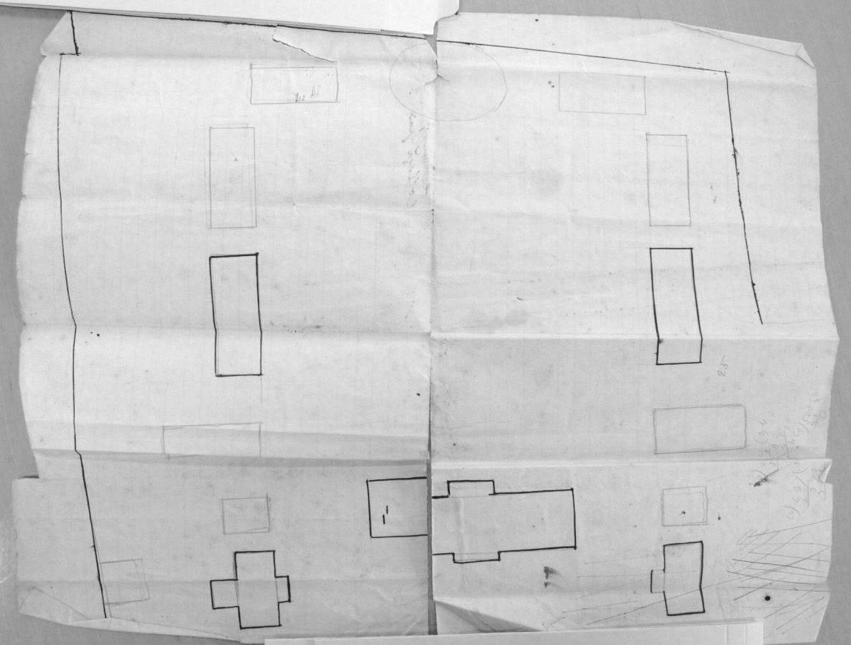
Figure 6- Henry's Freehand Drawing of the Plan for the College Grounds
The Board of Trustees approved Henry’s Campus plan and then followed with a resolution to build a new stone house for his use. (September 29, 1836) [10]. Stone made sense given that the two closest buildings to the proposed house were Nassau Hall and the Library, and both of these were constructed with stone from the local quarry:
“Resolved, that this Board adopt the plan, submitted by Professor Henry for the location of buildings on the College ground.
…
Resolved, that a house for Professor Henry be forthwith erected, that it be of stone, on the site shown by the plan of the grounds adopted by the board; and that a sum not exceeding four thousand dollars (with materials now in the house occupied by Professor Henry) be appropriated for that object.
Resolved, that Dr Carnahan, Mr Cooley and Mr Green be a committee to carry the immediate proceeding resolution into effect.”
Dr. James Carnahan was President of the College. Rev. Eli Field Cooley of Trenton (Princeton Class of 1806) and Mr. James Sprout Green of Princeton (lawyer and son of Carnahan’s predecessor, Dr. Ashbel Green) were Trustees of the College [3]. Pres. Carnahan served as the chairman of the Building Committee. We know Carnahan was chairman by comparing entries in the Treasurer’s general accounts for September 1838 and in the ‘Statement of Moneys Paid for Professor’s House’ in the Treasurers records of ‘Repairs for Joseph Henry House’ [25]. This same group previously had worked as a Building Committee to oversee construction of several other structures on the College grounds including the house that Prof. Dod occupied (built in 1827 also known as ‘Professor’s House’ – this house was first occupied by Prof. Patton), East College (1832-33), and West College (1835-36) [26].
The Whig Society was successful in raising the funds, and local builder Charles Steadman agreed to construct the new Whig Hall for $7000. Architect John Haviland of Philadelphia provided a Greek revival design for Whig. The cornerstone of Whig Hall was laid in summer of 1837 and it was completed by the autumn of 1838 [26, 27]. Henry’s Campus Plan was not followed precisely as reflected in an annotation in his personal copy of the 1836 Whig circular [28]. The handwritten note below shown in Figure 7 was added to the printed circular sometime after Henry returned from an April - September 1837 trip to Europe.
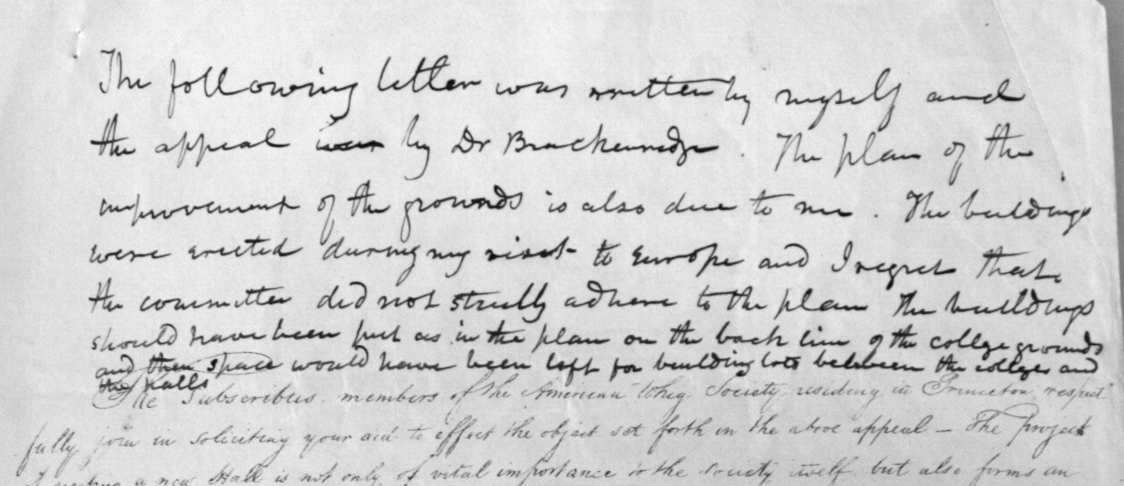
Figure 7- Henry's hand written note added to the 1836 Whig Circular
“The following letter [that is, the text in the lithographed circular] was written by myself and the appeal [was] by Dr Brackenridge. The plan of the improvement of the grounds is also due to me. The buildings were erected during my visit to Europe and I regret that the committee did not strictly adhere to the plan. The buildings should have been put as in the plan on the back line of the college grounds and then space would have been left for building lots between the colleges and the halls”.
The ‘building lots’ the he refers to, are understood by looking at Figure 6 which shows lightly drawn rectangles for two additional buildings between the Society Halls and the New Colleges. One also sees that Henry envisioned two other buildings, symmetrical about Nassau Hall, and between the proposed houses and the new Colleges. The circle on the back of the drawing in Figure 6 is identified as ‘site reserved for chapel’ in Figure 5. The chapel was eventually located elsewhere, and that circled site became a privy.

Joseph Henry’s Design for the Professor’s House
With the Board of Trustees granting permission for the construction of a new professor’s house, Henry submitted a design to the Building Committee [12]. Though Henry was not a practicing architect, he understood architectural principles and even lectured on architecture to Princeton students [29]. Figure 8 shows his sketch dated January 1837 (Henry’s annotation on the reverse side “Plan of a house submitted to the building committee of college. This was the plan submitted by myself” addressed to Pres. James Carnahan). On April 11 of the same year, the Board of Trustees directed the Building Committee to proceed with the construction of the house [13]. (Trustee meetings were held in April and September. Princeton’s commencement in this period was held in September.) From the April 1837 Trustees minutes:
“The subject of Professor Henry's house was taken up; and it was on motion. Resolved, that the building committee proceed as soon as they shall think it expedient, to erect a dwelling house, agreeably to the plan submitted to said Committee, by Professor Henry.

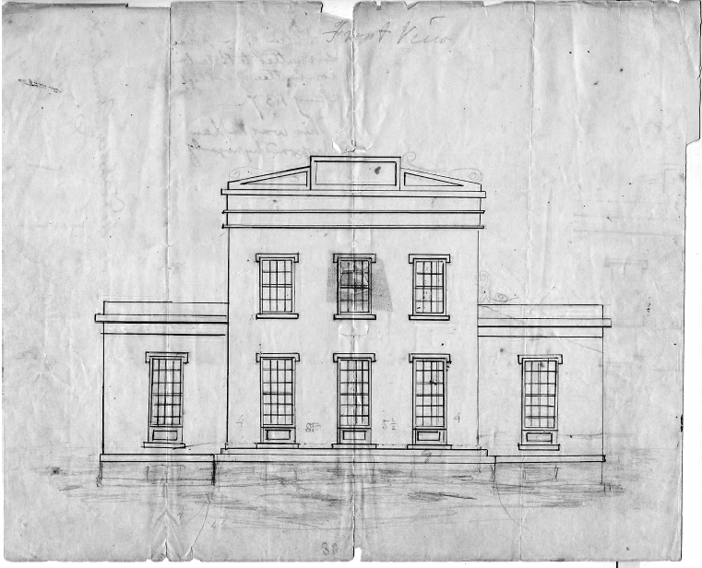
Figure 8- Henry's Proposed Design of a Professor’s House, submitted to Building Committee January 1837
Figure 9 – The Professor’s House that was built in Earliest Known Photograph - 1863
Henry’s January 1837 design looks nothing like the structure that was built. The house that was constructed in 1838 is shown in Figure 9 – this is the earliest known photograph of the Joseph Henry House. Today the brick has been painted light yellow. The stone structure to the right of the House is the Library (now known as Stanhope Hall). Both the Library and its twin, Philosophical Hall, were designed by Benjamin Latrobe, the designer of the US Capitol. It is interesting that Henry’s new house is similar in style to the Vice President’s House (building F in Figure 5 of 1836, and the leftmost building of Figure 3 of 1825) [30]. The Vice President’s House was constructed in 1799 in a classic Federal Style, modified in 1832-34 [3 bays increased to 5 bays and Greek Revival Portico added], and demolished in 1873 [1]. A photograph of the Vice President’s House in 1870 is shown in Figure 10. This is how Prof. Maclean’s house appeared in the first few years after Henry joined the faculty.
Figure 10 – The Vice President’s House (constructed in 1799 – portico and addition in 1832)
Prof. Dod’s house was to the east of East College and it too was in a Federal Style with a Greek Revival Portico. Figure 11 shows this house in a lithograph [31] and in a photograph [32]. Two houses are shown in the lithograph. The house on the left is Henry’s House that was relocated in 1870 to make way for Reunion Hall. The house to its right is that of Prof. Dod who occupied it in Henry’s time. Prof. Dod’s house was removed in 1881 to make way for Marquand Chapel.
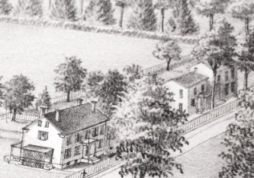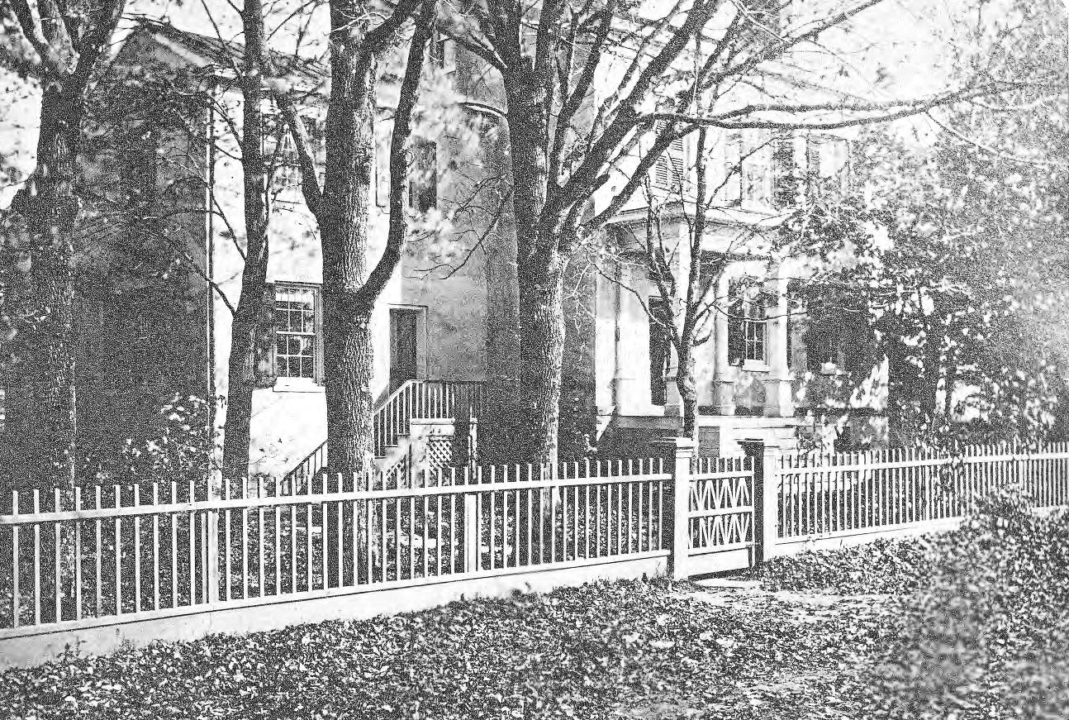
Figure 11 – Prof Dod’s House shown in lithograph and photograph, circa 1875
Knowing that Henry’s proposed house design is so different than the structure that was built, brings into question as to what the phrase ‘agreeable to the plan submitted’ refers to in the April 1837 Trustee’s resolution [13]. Did ‘plan’ refer to Henry’s design of a house or did it refer to his site plan? The similarity in style of Henry’s house to the existing and nearby Vice President’s house also suggests that perhaps the Building Committee made the design decision to have the new professor’s house look like other professor’s houses on the campus. We know that this Building Committee was in the habit of making design decisions with regards to structures that they oversaw including Prof. Patton’s house, which was built in 1827 by carpenter Charles Steadman. From many bills in the College Treasurer’s files, we know also that this Building Committee supervised the construction of East College in 1832-33 and repairs to the President’s House in 1836 [33]. These later two structures drew heavily upon the skilled labor of mason Ezekial Howell and his employees.

Construction of the House
Although the Trustees minutes mention in September 1837 that construction of the professor’s house was to commence “without any delay”, construction did not begin until early 1838. We know from a letter sent to Joseph Henry that his old house was dismantled in November 1837 [34]. We know also that Henry and his family occupied a rented house in the nearby Princeton Theological Seminary, fully covered by the College [35]. The Trustee’s Minutes from September 26, 1837 state,
“Resolved, that a sum not exceeding three hundred dollars, be appropriated for the rent of a house for Professor Henry, for the present year.”
We know also from the Building Committee’s minutes that there was difficulty in securing funding. College finances were not the best and at this time it was common for individual Trustees to loan moneys to the struggling College. A member of the Trustees expressed the desire to get started quickly and he offered to loan funds to begin construction. That Trustee member was not named in these documents, but in the April 1838 records of the Treasurer there is a credit to Trustee Robert Lenox for $1500 in support of Professor Henry’s house. Lenox was the chairman of the Finance Committee who in 1835 had recommended that Henry’s original house be expanded. In the April 1838 Trustee Minutes, the Building Committee announces its decision to substitute “brick for stone” [36]. No explanation is given or was found for this switch. Financial records found concerning the construction of the house show that Daniel Dougherty dug the cellar. He was paid $35.00 for this on April 12, 1838 – the work was presumably completed by then [25]. Dougherty was a regular employee of the College whenever digging was needed. We also know from the personal diary of Rev. Cooley, who served as the agent overseeing most expenses related to the House, that Ezekial Howell began work on the house on or about April 8th 1838 [37]. Howell received substantial payments at regular intervals over the next several months. It is very clear from the Treasurer’s records of bills and payments [38], and from Cooley’s diary entries that Ezekial Howell is the principal builder of the Joseph Henry House.
We know that Henry’s house was completed by mid-September 1838. Henry himself told his brother, James Henry, in a letter that he finishes on September 13, 1838 [39],
“We are just about to move and hope to get into the new house in the course of the present week … We commenced to move to day and expect to get through by tomorrow night.”
There are also a few bills in mid-September for leveling of the ground, and for fences, and the like – expenses that one would expect at the end of a project. Some of these final bills and a few earlier ones involved Steadman – his personal expertise was carpentry. During the time that the Henry house was being constructed by Howell, Steadman was building Whig Hall on the back campus, only a few hundred feet away. A cumulative statement listing the money paid for the House shows that the last payment prior to the Trustees meeting was entered on September 27, 1838, when construction was mostly finished. At that point the total expenditures for the House tallied $5754.79, or roughly 50% over the original $4000.00 budgeted.
At the following Trustees meeting in April 1839, on the reconciliation of the Treasurer’s records, there is yet another bill for “contingent expenses associated with the professor’s house” which amount to $328.85. These additional expenses include bills that were not included in September 1838 reconciliation including bills from Charles Steadman for labor costs in the construction of a wooden stable associated with the House and a warrant (payment) dated September 18, 1838 for “drawings of the professor’s house”. Judging from many other bills and warrants associated with Charles Steadman for many other Princeton College projects, he would submit his bills at the end of a construction project and then receive payment. Sometimes his bills were not submitted for many months after the project was finished. For example, Steadman was regularly hired to construct the College commencement stage in September. His bills for such work would not be submitted or paid until the following March or April. Steadman’s warrant below in Figure 12 shows that he was responsible for the drawings of Henry’s house, but perhaps he was not its designer.
Figure 12 - Charles Steadman's Bill for Drawings of Professor’s House

Case for Steadman as designer
From bills and Treasurer’s record of general accounts [38], we know that Daniel Dougherty was the digger, Ezekial Howell was the primary builder, Charles Steadman was the draftsman, and Rev. Eli Cooley was the financial agent. Today we would describe Rev. Cooley as the general contractor. We know also that this same Building Committee was responsible for the construction of East College six years earlier. The design for East College reputedly came from the Committee. With regards to the house that Prof. Dod occupied, we know that Charles Steadman was its builder and that he was responsible for the design. That house, constructed in 1827, was located east of East College. The ‘article of agreement’ with Steadman compares that house to another one that he previously designed and built for a Princeton resident (Mrs. Field). Steadman’s 1827 house is labeled in Figure 13 below as Prof. Packard’s House in a map of the College campus that appeared in March 1876 in Scribner’s Monthly [40].
Figure 13 – 1876 engraving – Packard’s house built by Steadman in 1827 – Karge’s house is Henry House relocated in 1870
The house labeled Prof. Karge’s in Figure 13 is the relocated Henry house, which was moved in 1870 to make room for Reunion Hall. There is an interesting crossed out entry in the ‘rough minutes of the Trustees’ that never made it into the final minutes of the Trustees that “the house for Professor Henry be similar in size and accommodation to that of Prof. Dod”. Given that Prof. Dod’s house was designed by Steadman, it would make sense that Steadman would be asked to design Henry’s house. Unfortunately, no similar ‘article of agreement’ has been found for Henry’s house, which would likely clarify the matter.
The best case for Steadman as designer, though, is circumstantial – The Joseph Henry House looks so much like other known Steadman houses in the local area including ones that did not involve the Building Committee. Constance Greiff in her book, “Princeton Architecture”, also notes the similarity of style of the Henry House to those constructed by Steadman [1]. Figure 14 shows a wooden 5-bay Steadman house (built for Steadman’s two daughters) that was right next door to house of Building Committee member, James S. Green. This house is especially close in appearance to the Henry House. Green, himself, lived in a 3-bay house that Steadman also built. A recent photograph of the Joseph Henry House at its present location is given in Figure 15. The comparison is striking. We think that If Henry played any role in the design of the house that now bears his name, it was to instruct Steadman to make his new house look like others that Steadman had been building in the area.
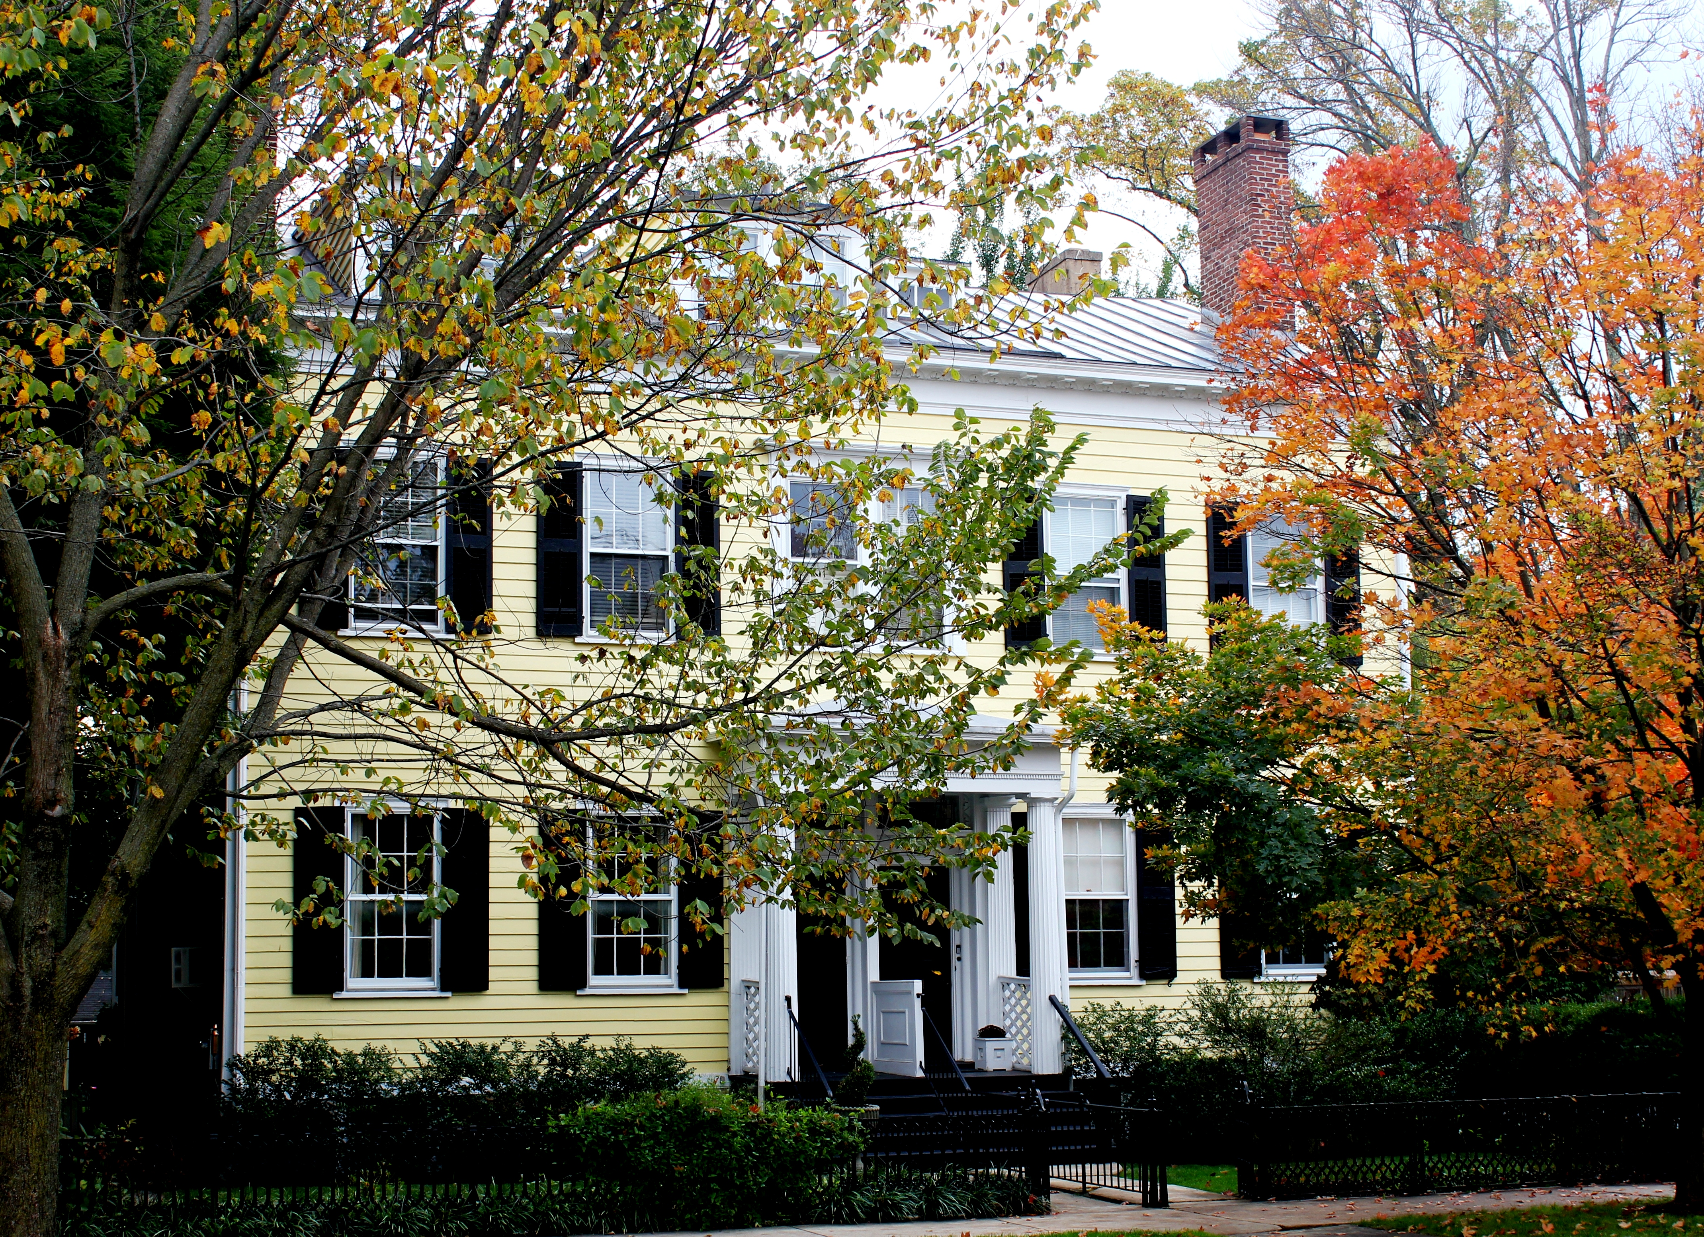
Figure 14 – Steadman House at 40-42 Mercer Street – James S. Green, Building Committee member, lived next door
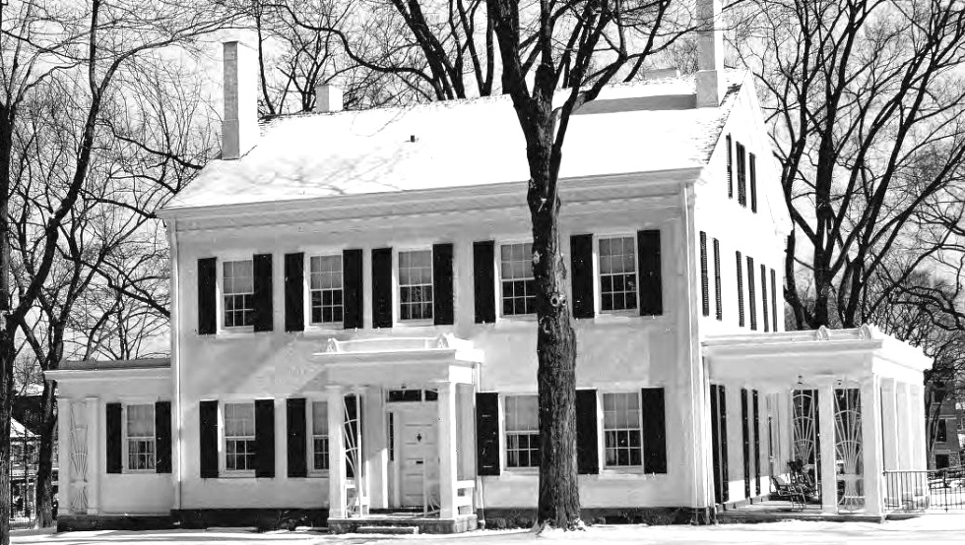
Figure 15 – Joseph Henry House at its current location – left and right porches added later

Henry’s Houses and Electromagnetism
Joseph Henry's residences entered into his experiments on electromagnetism. The house that he occupied from 1832 until 1837 was used in 1836 for a demonstration of a critical improvement in telegraphy. Henry describes his telegraph experiments in a letter to Dod in 1876 [41].
“I think that the first actual line of telegraph using the Earth as a conductor was made in the beginning of 1836. A wire was extended across the front campus of the college grounds from the upper story of the library building to the philosophical hall on the opposite side, the ends terminating in two wells. Through this wire, signals were sent, from time to time, from my house to my laboratory. The electro-magnetic telegraph was first invented by me, in Albany, in 1830. Prof. Morse, according to his statements, conceived of the idea of an electro-magnetic telegraph in his voyage across the ocean in 1832, but did not until several years afterward – 1837 – attempt to carry his ideas into practice; and when he did so, he found himself so little acquainted with the subject of electricity that he could not make his simple machine operate through the distance of a few yards. In this dilemma he called in the aid of Dr. Leonard D. Gale, who was well acquainted with what I had done in Albany and Princeton, having visited me in the latter place.”
Henry’s new house of 1838 similarly was used in his experiments – Here, Henry detects lightning flashes some 8 miles distant by magnetizing steel needles inserted in a spiral of what is in essence a receiving antenna. In the same letter to Dod, Henry recalls,
“The next series of experiments …. was on the induction from thunder clouds. For this purpose the tin covering of the house in which I resided was used as an inductive plate. A wire was soldered to the edge of the roof near the gutter, was passed into my study and out again through holes in the window-sash, and terminated in connection with a plate of metal in a deep well immediately in front of the house. By breaking the continuity of that part of the wire which was in the study, and introducing into the opening a magnetizing spiral, needles placed in this could be magnetized by a flash of lightning so distant that the thunder could scarcely be heard. The electrical disturbance produced in this case was also found to be of an oscillatory character, a discharge first passing through the wire from the roof to the well, then another in the opposite direction, and so on until equilibrium was restored.”
It is noteworthy that Henry’s detection of radio frequency interference here occurs more than 40 years before the well-known transmission and detection of radio waves of Heinrich Hertz.

Conclusion
With the discussion above, a few points can now be made assuredly. First, Henry was responsible for the influential plan that placed several buildings along a long rectangle centered on Nassau Hall, including his own home. Henry’s plan allowed for an unobstructed view of Whig and Clio Halls as seen from Nassau Street. The fact that the central Princeton campus is not cluttered with buildings is rightly credited to Joseph Henry. Second, Charles Steadman drafted the plans for Henry’s house, and had earlier designed and built a different professor’s house of a similar style. Given that the Joseph Henry House so closely resembles others that Steadman built in Princeton, including those constructed before Henry ever arrived in Princeton, argues that Steadman was involved in the design – but this is not conclusive. Lastly, the House is remarkable because of its distinguished occupant and the connection to the early history of electromagnetism, but not because of its design or designer.

Acknowledgements
We thank Daniel Linke of the Mudd Manuscript Library at Princeton University for his expert assistance in this study. We thank Architect Jeffrey Clarke for useful discussions. Mr. Clarke was responsible for the 1999 restoration of the Joseph Henry House. Ms. Janet Temos, a former research asssistant with Prof. R. J. Clark, provided guidance that helped us find many original documents. Ms. Constance Greiff is thanked for reviewing an early draft of the manuscript. Finally we are appreciative of the Smithsonian archives for providing access to original Joseph Henry documents on deposit at the Smithsonian.

Bibliography

- Greiff, C. M., Gibbon, M. W., and Menzies, E. G. C. 1975. Princeton Architecture. Princeton: Princeton University Press.
- Breese, G. and Coleman, E. E. 1986. Princeton University Land: 1752-1984. Princeton: Princeton University Press.
- Wertenbaker, T. J. 1946. Princeton 1746-1896. Princeton: Princeton University Press.
- Hageman, J. F. 1879. History of Princeton and Its Institutions Vols. 1 and 2. Philadelphia: J. B. Lippincott & Co.
- Leitch, A. 1978. Princeton Companion. Princeton: Princeton University Press.
- Clark, R. J. "Joseph Henry House". Robert Judson Clark Papers, Princeton University Archives, Department of Rare Books and Special Collections, Princeton University Library - AC208, Box 4, Folder 92.
- Clark, R. J. "Joseph Henry House". Robert Judson Clark Papers, Princeton University Archives, Department of Rare Books and Special Collections, Princeton University Library - AC208, Box 9, Folder 19.
- Henry Dawkins (engraver) after a drawing by William Tennent, “A North-West Prospect of Nassau-Hall, with a Front View of the President’s House in New Jersey. “Engraved frontispiece for: An Account of the College of New Jersey (Woodbridge, NJ, 1764). Rare Books (Ex) Oversize 6694.73.1764q, Princeton University Library.
- Letter from Charles Clinton Beatty, Class of 1755 (brother) to Enoch Green, Class of 1760; 1774 January 31; John Beatty Family Collection, Box 1, Folder 5; Manuscripts Division, Department of Rare Books and Special Collections, Princeton University Library.
- Trustee Minutes – September 29, 1936. Board of Trustees Minutes. Vol. 3, p.328. Princeton University Library, Department of Rare Books and Special Collections, Seeley G. Mudd Manuscript Library, Princeton University Archives - AC120.
- Letter (printed circular) to Whig members August 30, 1836. Subseries 12B: General Documents Relating to Construction; 1836-1892; American Whig Society Records, Princeton University Archives, Department of Rare Books and Special Collections, Princeton University Library.
- Henry, J. 1837. An Image of the Design of the Joseph Henry House (Figure 8). Smithsonian Institution Archives, Record Unit 7001, Box 49, Folder 1.
- Trustee Minutes – April 12, 1937. Board of Trustees Minutes. Vol. 3, p.333. Princeton University Library, Department of Rare Books and Special Collections, Seeley G. Mudd Manuscript Library, Princeton University Archives - AC120.
- “Joseph Henry’s Home in Princeton, NJ” (Figure 9). 1863. Smithsonian Institution Archives Image # SIA2012-2992
- W. F. Magie, “Joseph Henry”, Rev. Mod. Phys. Vol. 3, p. 465 (1931)
- Report of the Action of the International Electrical Congress held in Chicago August, 1893, in the Matter of Units of Electrical Measure, pp. 1-4, Box 27, Joseph Henry Collection, Record Unit 7001, Smithsonian Institution Archives
- “Prof. Henry’s Big Magnet”, Scientific American, Dec 11, p. 370 (1880).
- "Deposition of Joseph Henry, in the Case of Morse vs. O'Reilly," Sept. 1849, reprinted in Annual Report of the Board of Regents of the Smithsonian Institution...for the Year 1857 (Washington: William A. Harris, Printer; 1858), p. 110.
- M. Littman and L. Stern, “A New Understanding of the First Electromagnetic Machine: Joseph Henry’s Vibrating Motor”, Am. J. Phys., vol 79, p.172 (2011)
- A. E. Moyer, Joseph Henry, Smithsonian Institution Press, Washington 1997.
- Letter dated February 9, 1833 to James Henry, Papers of Joseph Henry, Vol. 2, Nov 1832 – Dec 1835, p. 45 -49, Nathan Reingold, ed., Smithsonian Institution Press (1975).
- Primitive Painting or Drawing, Reproduction; circa 1825; Nassau Hall Iconography, Box 1, Folder 7; Princeton University Archives, Department of Rare Books and Special Collections, Princeton University Library. After 1804/05: Shows Stanhope and Philosophical Halls; Before 1833: East College not shown. Size of trees indicates 1825.
- Trustee Minutes – September 29, 1935. Board of Trustees Minutes. Vol. 3, p.303. Princeton University Library, Department of Rare Books and Special Collections, Seeley G. Mudd Manuscript Library, Princeton University Archives - AC120.
- Henry, J. Early Sketch of the Campus Plan. Smithsonian Institution Archives, Record Unit 7001, Box 30, Folder 10.
- Office of the Treasurer’s Records: 1838 – “Repairs for Joseph Henry”. Office of the Treasurer Records, Princeton University Library, Department of Rare Books and Special Collections, Seeley G. Mudd Manuscript Library, Princeton University Archives - AC128, Box 1, Folder 40.
- Campus Grounds and Building; 1750-1995; Robert Judson Clark Papers, Princeton University Archives, Department of Rare Books and Special Collections, Princeton University Library.
- Steadman, C. 1837. "Articles of Agreement with American Whig Society to Build a Building for Them for $7000". Willard H. Bradford Princeton Collection, Manuscripts Division, Department of Rare Books and Special Collections, Princeton University Library - C0057, Box 1, Folder 27.
- Smithsonian Institution Archives, Record Unit 7001, Henry, Joseph, 1797-1878, Joseph Henry Collection. Box 7 of 65, Folder 19 July-December 1836 – Joseph Henry’s personal annotated copy of printed circular.
- Hunter, C. H. 1836. A note about “Lectures on Architecture to the Junior Class of 1836 at Nassau Hall by Prof. Joseph Henry.” Lecture Notes Collection, Princeton University Library, Department of Rare Books and Special Collections, Seeley G. Mudd Manuscript Library, Princeton University Archives - AC052, Box 22, Folder 6. …AND… Miller, J. 1836. A note about "Lectures on Civil Architecture by Prof. Henry of Nassau Hall". Lecture Notes Collection, Princeton University Library, Department of Rare Books and Special Collections, Seeley G. Mudd Manuscript Library, Princeton University Archives - AC052, Box 22, Folder 8.
- Princeton University Library. (Figure 10) 1861 Photograph. Department of Rare Books and Special Collections. Seeley G. Mudd Manuscript Library. Box MP87, Item 3563
- Princeton College, Princeton, N.J., 1875. Lithographed by Thomas Hunter, after a design by W. M. Radcliff. Published by Charles O. Hudnut and also called Hudnut’s Aerial View. GC047 Princetoniana Collection, Princeton University Library.
- Princeton University Library. (Figure 11) Prof. Karge’s House. Department of Rare Books and Special Collections. Seeley G. Mudd Manuscript Library.. Box SP04, Item 969
- Office of the Treasurer’s Records: 1835-1838. Office of the Treasurer Records, Princeton University Library, Department of Rare Books and Special Collections, Seeley G. Mudd Manuscript Library, Princeton University Archives - AC128, Box 3, Folder 4.
- Letter dated Nov. 1, 1837 from John Torrey, Papers of Joseph Henry, Vol. 3, Jan 1836 – Dec 1837, p. 516, Nathan Reingold, ed., Smithsonian Institution Press (1979).
- Trustee Minutes – September 26, 1937. Board of Trustees Minutes. Vol. 3, p.338. Princeton University Library, Department of Rare Books and Special Collections, Seeley G. Mudd Manuscript Library, Princeton University Archives - AC120.
- Trustee Minutes – April 10, 1938. Board of Trustees Minutes. Vol. 3, p.343. Princeton University Library, Department of Rare Books and Special Collections, Seeley G. Mudd Manuscript Library, Princeton University Archives - AC120.
- Cooley, E. F. Diaries (1836-1839). Eli Field Cooley Papers, Manuscripts Division, Department of Rare Books and Special Collections, Princeton University Library - C0410, Box 7, Folder 5.
- Inspector's Records 1837-1838. Inspector's Records, Princeton University Archives, Department of Rare Books and Special Collections, Princeton University Library - AC031 Box 1, Folders 9-11. …AND…Office of the President Records : Jonathan Dickinson to Harold W. Dodds Subgroup, Papers 8: College Finances of 1830-1859. Office of the President Records : Jonathan Dickinson to Harold W. Dodds Subgroup, Princeton University Archives, Department of Rare Books and Special Collections, Princeton University Library - AC117, Box 25, Folder 1. …AND… Office of the President Records : Jonathan Dickinson to Harold W. Dodds Subgroup, Papers 36: Trustee Minutes: (a) Building Committee of 1836-1847. Office of the President Records : Jonathan Dickinson to Harold W. Dodds Subgroup, Princeton University Archives, Department of Rare Books and Special Collections, Princeton University Library - AC117, Box 32, Folder 5. …AND… Office of the Treasurer’s Records: 1835-1838. Office of the Treasurer Records, Princeton University Library, Department of Rare Books and Special Collections, Seeley G. Mudd Manuscript Library, Princeton University Archives - AC128, Box 3, Folder 4. …AND…. Board of Trustees Records: Rough Minutes, Letters, Accounts - 1838 April. Board of Trustees Records, Princeton University Archives, Department of Rare Books and Special Collections, Princeton University Library - AC120, Box 7, Folder 18.
- Letter to James Henry, Sept 11-13, 1838, Papers of Joseph Henry, Vol. 4, Jan 1838 – Dec. 1840, p.111-112, Nathan Reingold, ed., Smithsonian Institution Press (1981).
- Scribner’s Monthly, “Princeton College”, Vol. 13, p.625, Scribner & Co., NY (1876).
- Henry’s letter to Dod in, A Memorial to Joseph Henry, US Government Printing Office, p.150-153 (1880).

