Joseph Henry’s House and Campus Plan
Ezra Y. S. Tjung, Daniel Kaufmann, Michael G. Littman

Abstract
Joseph Henry is sometimes credited with the design of the Joseph Henry House, a registered National Historic Landmark on the Princeton University Campus. Joseph Henry was Professor of Natural Philosophy and Mathematics at Princeton College at the beginning of the 19th century. He also taught Architecture and Geology, and had worked earlier in the State of New York as a surveyor. We set out to verify that Joseph Henry was responsible for the design of the House that bears his name, and found to our surprise that it is unlikely that he designed it. Our conclusion is based on a review of many financial documents and other records of the College, published and unpublished papers and letters of Joseph Henry, and a diary of a key member of the College Building Committee. We have established that Ezekial Howell, a local mason, was the principal builder of the House. We have also determined that Charles Steadman, a local carpenter and builder, was responsible for drawings of the House. While it is possible that Steadman as draftsman was following Henry’s specifications, we find that this is unlikely given that the House constructed in 1838 is so similar to many others built by Steadman in the Princeton area. Prof. Henry did make his own drawing of a house and submitted it to the Building Committee, but his design is not at all like the design of the house that was built. That withstanding, Joseph Henry did select the location of the House as well as that of several other early buildings as part of his influential Campus Plan. A previously unknown freehand draft of the Campus Plan was discovered indicating location of several unrealized buildings.

Keywords: Joseph Henry, The College of New Jersey, Princeton University, Joseph Henry House, Charles Steadman, Dr. James Carnahan, Rev. Eli Field Cooley, James Sprout Green, Esq. Smithsonian Institution,

Introduction
Built in 1838 and named a National Historic Landmark in 1965, the Joseph Henry House is one of the earlier structures at the College of New Jersey (now Princeton University). The House has been moved three times – perhaps a record – but its original location was close to the College’s two original buildings, Nassau Hall and the President’s House. Both of these structures still exist. Princeton College and its grounds are shown in the 1764 engraving by Henry Dawkins in Figure 1. Today we would describe this engraving as showing the entire College campus. ‘Campus’ is latin for ‘field’, and its first use anywhere to describe college grounds was in reference to the fenced yard in front of Nassau Hall.
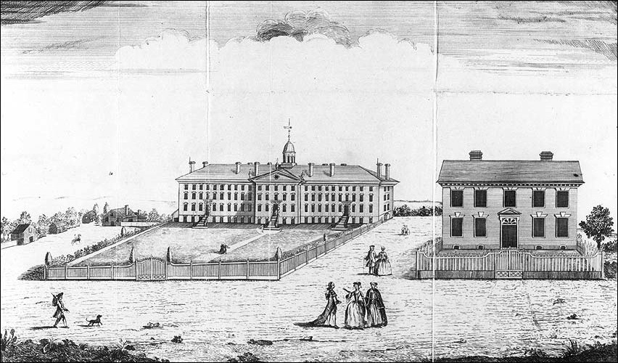
Figure 1 – College of New Jersey – Nassau Hall and the President’s House - 1764
Joseph Henry proposed a plan for development of Princeton College in 1836. His plan was accepted by the Trustees. Henry’s plan included a new location for his home, as well as placement of several proposed additional buildings. This plan called for a building arrangement that was symmetrical about Nassau Hall. Joseph Henry was hired in 1832 to teach Natural philosophy and Mathematics. He served as Princeton faculty member for fourteen years in a time when the entire faculty (tutors and professors) numbered about ten. Besides Natural Philosophy and Mathematics, he also taught courses in Geology, and Architecture. He moved to Washington DC in 1846 to establish and lead the Smithsonian Institution as its first Secretary.
The Joseph Henry House is a brick dwelling of Federal-Greek Revival style and identified by many sources to have been designed by Prof. Henry himself. Henry and his family members were its first occupants when the construction was completed in mid-September 1838. A study of the House and documents relating to its origins, reveal interesting facts but no evidence at all that Joseph Henry designed it. Henry did present a drawing to the Trustees in January 1837 for a house, but this drawing bears no resemblance to the house that was built. The brick house as built, however, is very similar to many wooden houses in the Princeton area constructed by Charles Steadman, suggesting that perhaps he may have been involved in the design.

Early Days in Princeton
Prof. Henry is best known for his many fundamental contributions in the field of electromagnetism and especially for his discovery of self-inductance. The Standard International (SI) unit of electrical inductance, the henry, is named after him. He is also known for discovering how to apply electromagnetism for the transmission of information and power by demonstrating a crude telegraph and a “toy” electric motor that others would bring into practical reality. Henry moved to Princeton in 1832 from the Albany Academy where he taught Mathematics and Natural Philosophy for eight years. Upon arriving in Princeton, Joseph Henry was provided use of a house that stood immediately to the west of Nassau Hall. At that time there were three professor’s houses; one occupied by the Prof. of Chemistry and Vice President John Maclean Jr.; another by Prof. of Mathematics Albert Dod; and the third by Prof. Henry and his family. Henry’s assigned home had been used previously by Prof. Henry Vethake, the faculty member that he was replacing. Figure 2 is a map drawn by Prof. Henry for his brother, James Henry, in an 1833 letter. Henry’s house, labeled “our house” in Figure 2, can be seen also in Figure 3, a circa 1825 drawing of the front campus by an unknown artist. Henry’s original house is located immediately to the right of Nassau Hall in Figure 3 and it faces the street (Nassau Street). Figure 4 shows a cropped image of this house that exhibits 5 bays in a Federal style. The house to the left of Nassau Hall in Figure 3 (labeled as the “steward’s house” in Figure 2) is visually similar to Henry’s house.

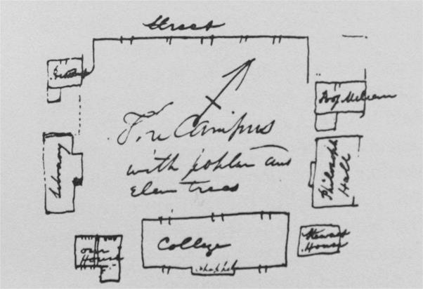
Figure 2 - Henry's map of the Front Campus with Poplar and Elm Trees - 1833

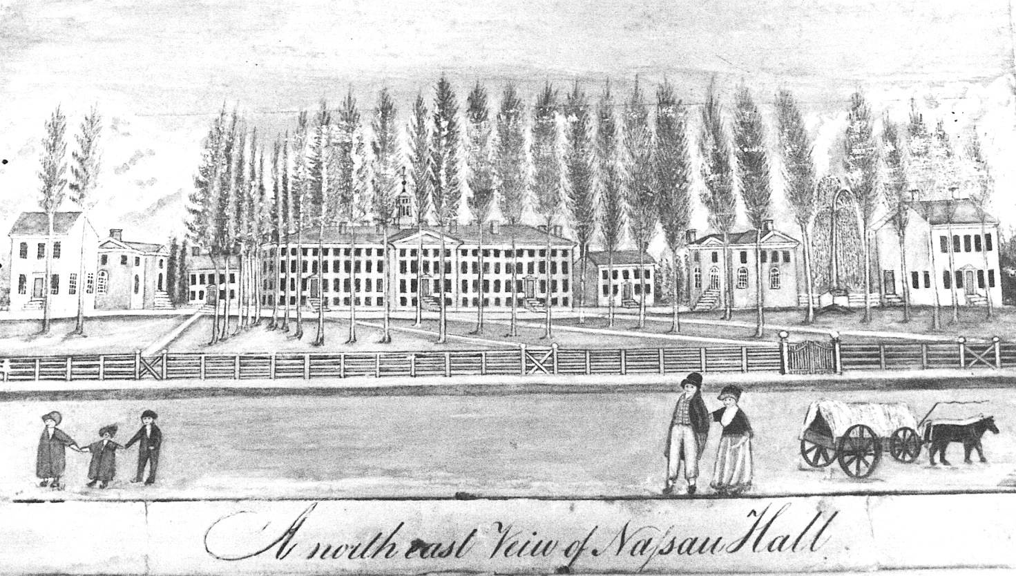
Figure 3 – Drawing of Princeton’s Front Campus as seen from Street - circa 1825

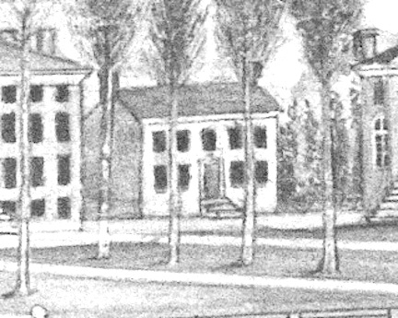
Figure 4 – Cropped view of the Professor’s House occupied by Joseph Henry until 1837

On September 29, 1835, the Board of Trustees decided to expand Henry’s house.
“Resolved that an addition be made to the house of Professor Henry, by erecting a wing on the southwest end of the house, which shall contain four comfortable rooms of such materials, and on such plan as the building committee may judge proper, and that the funds necessary for completing this addition be procured in the same manner, as prescribed in the second resolution [that is, to get loan from a bank].”

Henry’s Campus Plan
Besides being the Professor of Natural Philosophy and Mathematics, Henry was also a member of Whig Society. The Whig Society was one of two debating clubs at the College - the other was The Cliosophic Society. Both debating societies are still active at Princeton University. In an 1836 lithographed circular, an appeal for funds was made to build a new hall for the Society. Henry drew a plan for the campus that was included in this document. In the letter to members, it is written,
"The erection of the new Halls is intimately connected with the improvement of the College grounds, as these edifices can be so placed in reference to the buildings now erected as to form with the latter a convenient and beautiful architectural arrangement. The plan of the disposition of the whole will readily be understood by a reference to the annexed Map."
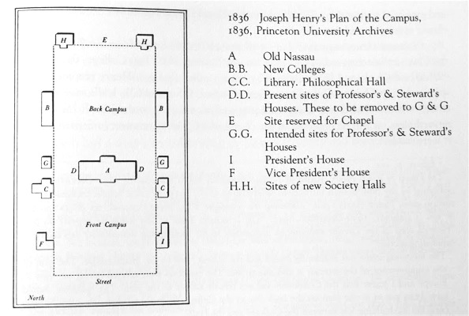
Figure 5 - Henry's Campus Plan of 1836

At the time of this letter, buildings A (Nassau Hall), B-left, C-left, C-right, F, and I were already present. Building B-right (today known as West College) was under construction. Buildings G-left, G-right, H-left, and H-right did not yet exist. Two existing structures, D-left (“steward’s house”) and D-right (“our house”), were proposed for relocation to G-left and G-right. Prior to the construction of the Halls, the debating societies met in the C-right (Library). We discovered an earlier freehand draft of the printed Campus Plan in the Smithsonian Institution Archives along with other Joseph Henry documents. This freehand version of the Figure 5 plan is shown in Figure 6. Henry’s wished to continue the strict symmetry of the Campus by pairing new buildings on each side of Nassau Hall at a respectful distance. At the rear of the campus, Whig Hall is paired with Clio Hall. East-West symmetry was already present, but Henry added to the concept of a back campus delineated with the proposed Halls. Henry proposed also that his house be set in alignment with the front of the Library (today known as Stanhope Hall) and West College.
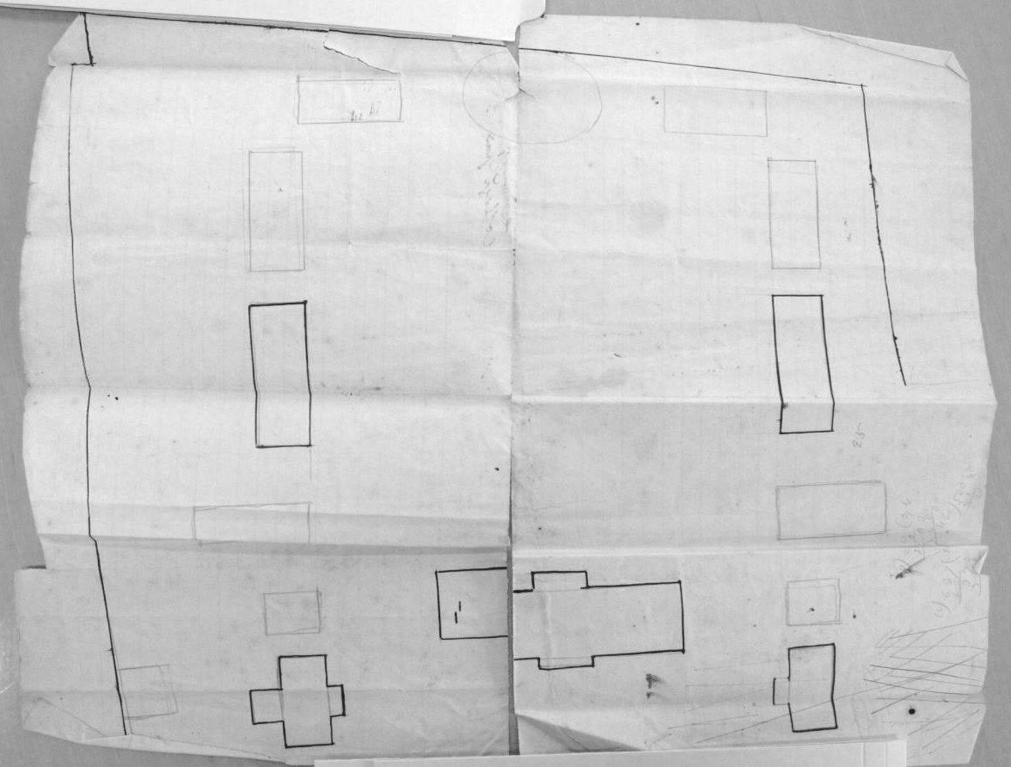
Figure 6- Henry's Freehand Drawing of the Plan for the College Grounds
The Board of Trustees approved Henry’s Campus plan and then followed with a resolution to build a new stone house for his use. (September 29, 1836). Stone made sense given that the two closest buildings to the proposed house were Nassau Hall and the Library, and both of these were constructed with stone from the local quarry:
“Resolved, that this Board adopt the plan, submitted by Professor Henry for the location of buildings on the College ground.
…
Resolved, that a house for Professor Henry be forthwith erected, that it be of stone, on the site shown by the plan of the grounds adopted by the board; and that a sum not exceeding four thousand dollars (with materials now in the house occupied by Professor Henry) be appropriated for that object.
Resolved, that Dr Carnahan, Mr Cooley and Mr Green be a committee to carry the immediate proceeding resolution into effect.”
Dr. James Carnahan was President of the College. Rev. Eli Field Cooley of Trenton (Princeton Class of 1806) and Mr. James Sprout Green of Princeton (lawyer and son of Carnahan’s predecessor, Dr. Ashbel Green) were Trustees of the College. Pres. Carnahan served as the chairman of the Building Committee. We know Carnahan was chairman by comparing entries in the Treasurer’s general accounts for September 1838 and in the ‘Statement of Moneys Paid for Professor’s House’ in the Treasurers records of ‘Repairs for Joseph Henry House’. This same group previously had worked as a Building Committee to oversee construction of several other structures on the College grounds including the house that Prof. Dod occupied (built in 1827 also known as ‘Professor’s House’ – this house was first occupied by Prof. Patton), East College (1832-33), and West College (1835-36).
The Whig Society was successful in raising the funds, and local builder Charles Steadman agreed to construct the new Whig Hall for $7000. Architect John Haviland of Philadelphia provided a Greek revival design for Whig. The cornerstone of Whig Hall was laid in summer of 1837 and it was completed by the autumn of 1838. Henry’s Campus Plan was not followed precisely as reflected in an annotation in his personal copy of the 1836 Whig Circular. The handwritten note below shown in Figure 7 was added to the printed Circular sometime after Henry returned from an April - September 1837 trip to Europe.
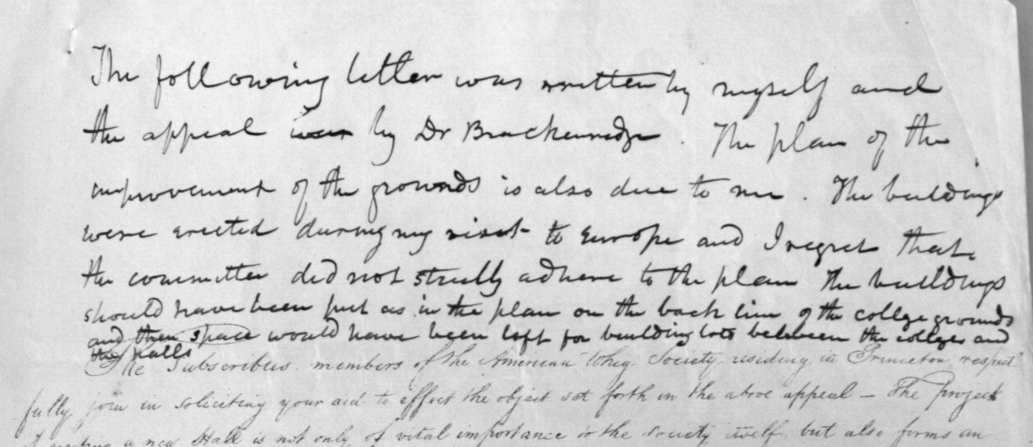
Figure 7- Henry's hand written note added to the 1836 Whig Circular
“The following letter [that is, the text in the lithographed circular] was written by myself and the appeal [was] by Dr Brackenridge. The plan of the improvement of the grounds is also due to me. The buildings were erected during my visit to Europe and I regret that the committee did not strictly adhere to the plan. The buildings should have been put as in the plan on the back line of the college grounds and then space would have been left for building lots between the colleges and the halls”.
The ‘building lots’ the he refers to, are understood by looking at Figure 6 which shows several lightly drawn rectangles for two additional buildings between the Society Halls and the New Colleges. One also sees that Henry envisioned two other buildings, symmetrical about Nassau Hall, and between the proposed houses and the new Colleges. The circle on the back of the drawing in Figure 6 is identified as ‘site reserved for chapel’ in Figure 5. The chapel was eventually located elsewhere, and that circled site became a privy.

Joseph Henry’s Design for the Professor’s House
With the Board of Trustees granting permission for the construction of a new professor’s house, Henry submitted a design to the Building Committee. Though Henry was not a practicing architect, he understood architectural principles and even lectured on architecture to Princeton students. Figure 8 shows his sketch dated January 1837 (Henry’s annotation on the reverse side “Plan of a house submitted to the building committee of college. This was the plan submitted by myself” addressed to Pres. James Carnahan). On April 11 of the same year, the Board of Trustees directed the Building Committee to proceed with the construction of the house. (Trustee meetings were held in April and September. Princeton’s commencement in this period was held in September.) From the April 1837 Trustees minutes:
“The subject of Professor Henry's house was taken up; and it was on motion. Resolved, that the building committee proceed as soon as they shall think it expedient, to erect a dwelling house, agreeably to the plan submitted to said Committee, by Professor Henry.

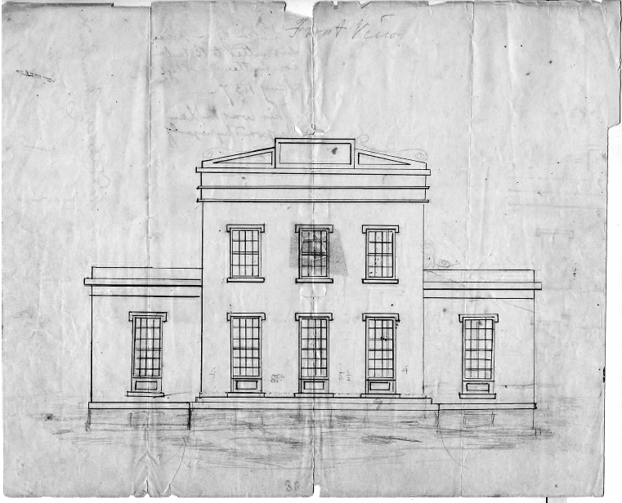
Figure 8- Henry's Proposed Design of a Professor’s House, submitted to Building Committee January 1837
Figure 9 – The Professor’s House that was built in Earliest Known Photograph - 1863
Henry’s January 1837 design looks nothing like the structure that was built. The house that was constructed in 1838 is shown in Figure 9 – this is the earliest known photograph of the Joseph Henry House. Today the brick has been painted light yellow. The stone structure to the right of the House is the Library (now known as Stanhope Hall). Both the Library and its twin, Philosophical Hall, were designed by Benjamin Latrobe, the designer of the US Capitol. It is interesting that Henry’s new house is similar in style to the Vice President’s House (building F in Figure 5 of 1836, and the leftmost building of Figure 3 of 1825). The Vice President’s House was constructed in 1799 in a classic Federal Style, modified in 1832-34 [3 bays increased to 5 bays and Greek Revival Portico added], and demolished in 1873. A photograph of the Vice President’s House in 1870 is shown in Figure 10. This is how Prof. Maclean’s house appeared in the first few years after Henry joined the faculty.
Figure 10 – The Vice President’s House (constructed in 1799 – portico and addition in 1832)
Prof. Dod’s house was to the east of East College and it too was in a Federal Style with a Greek Revival Portico. Figure 11 shows this house in a lithograph (1875 – Hunter) and in a photograph. Two houses are shown in the lithograph. The house on the left is the Henry House that was relocated in 1870 to make way for Reunion Hall. The house to its right is that of Prof. Dod who occupied it in Henry’s time. Prof. Dod’s house was removed in 1881 to make way for Marquand Chapel.
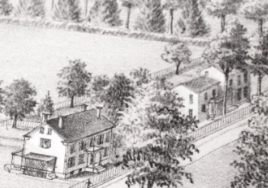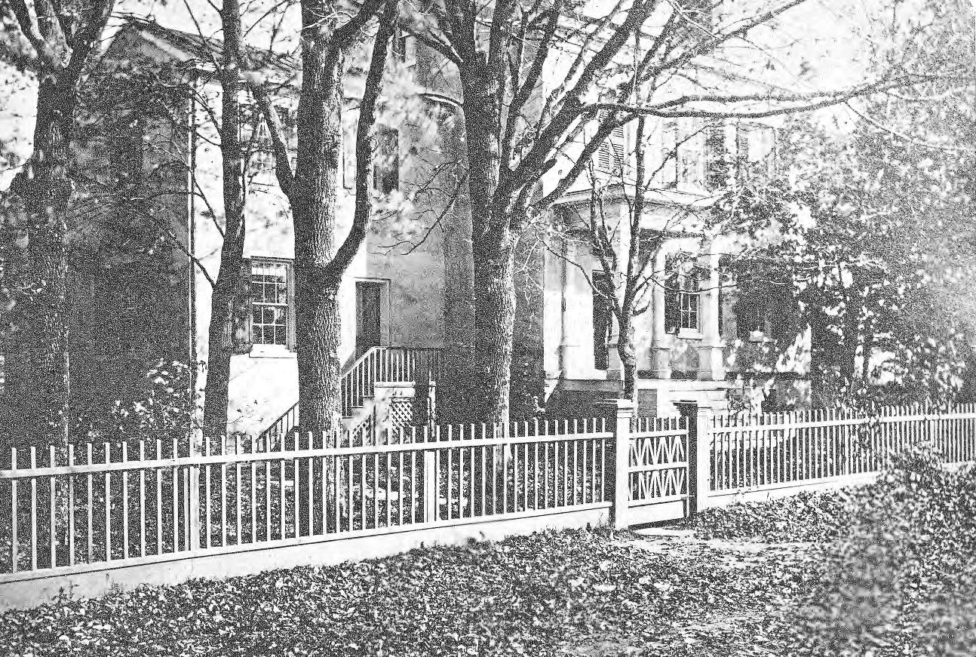
Figure 11 – Prof Dod’s House shown in lithograph and photograph, circa 1875
Knowing that Henry’s proposed house design is so different than the structure that was built, brings into question as to what the phrase ‘agreeable to the plan submitted’ refers to in the Trustee’s resolution. Did ‘plan’ refer to Henry’s design of a house or did it refer to his site plan? The similarity in style of Henry’s house to the existing and nearby Vice President’s house also suggests that perhaps the Building Committee made the design decision to have the new professor’s house look like other professor’s houses on the campus. We know that this Building Committee was in the habit of making design decisions with regards to structures that they oversaw including Prof. Patton’s house, which was built in 1827 by carpenter Charles Steadman. From many bills in the College Treasurer’s files, we know also that this Building Committee supervised the construction of East College in 1832-33 and repairs to the President’s House in 1836. These later two structures drew heavily upon the skilled labor of mason Ezekial Howell and his employees.

Construction of the House
Although the Trustees minutes mention in September 1837 that construction of the professor’s house was to commence “without any delay”, construction did not begin until early 1838. We know from a letter sent to Joseph Henry that his old house was dismantled in November 1837. We know also that Henry and his family were given a rented house in the nearby Princeton Theological Seminary, fully covered by the College. The Trustee’s Minutes from September 26, 1837 state,
“Resolved, that a sum not exceeding three hundred dollars, be appropriated for the rent of a house for Professor Henry, for the present year.”
We know also from the Building Committee’s minutes that there was difficulty in securing funding. College finances were not the best and at this time it was common for Trustees to loan moneys to the struggling College. A member of the Trustees expressed the desire to get started quickly and he offered to float a loan to begin construction. That Trustee member was not named in these documents, but in the April 1838 records of the Treasurer there is a credit to Trustee Robert Lenox for $1500 in support of Professor Henry’s house. Lenox was the chairman of the Finance Committee who in 1835 had recommended that Henry’s original house be expanded. At the April 1838 Trustee Minutes, the Building Committee announces its decision to substitute “brick for stone”. No explanation is given or was found for this switch. Financial records found concerning the construction of the house show that Daniel Dougherty dug the cellar. He was paid $35.00 for this on April 12, 1838 – the work was presumably completed by then. Dougherty was a regular employee of the College whenever digging was needed. We also know from the personal diary of Rev. Cooley, who served as the agent overseeing most expenses related to the House, that Ezekial Howell began work on the house on or about April 8th 1838. Howell received substantial payments at regular intervals over the next several months. It is very clear from the Treasurer’s records of bills and payments, and from Cooley’s diary entries that Ezekial Howell is the principal builder of the Joseph Henry House.
We know that Henry’s house was completed by mid-September 1838. Henry himself told his brother, James Henry, in a letter that he finishes on September 13, 1838,
“We are just about to move and hope to get into the new house in the course of the present week … We commenced to move to day and expect to get through by tomorrow night.”
There are also a few bills in mid-September for leveling of the ground, and for fences, and the like – expenses that one would expect at the end of a project. Some of these final bills and a few earlier ones involved Steadman – his personal expertise was carpentry. During the time that the Henry house was being constructed by Howell, Steadman was building Whig Hall on the back campus, only a few hundred feet away. A cumulative statement listing the money paid for the House shows that the last payment prior to the Trustees meeting was entered on September 27, 1838, when construction was mostly finished. At that point the total expenditures for the House tallied $5754.79, or roughly 50% over the original $4000.00 budgeted.
At the following Trustees meeting in April 1839, on the reconciliation of the Treasurer’s records, there is yet another bill for “contingent expenses associated with the professor’s house” which amount to $328.85. These additional expenses include bills that were not included in September 1838 reconciliation including bills from Charles Steadman for labor costs in the construction of a wooden stable associated with the House and a warrant (payment) dated September 18, 1838 for “drawings of the professor’s house”. Judging from many other bills and warrants associated with Charles Steadman for many other Princeton College projects, he would submit his bills at the end of a construction project and then receive payment. Sometimes his bills were not submitted for many months after the project was finished. For example, Steadman was regularly hired to construct the College commencement stage in September. His bills for such work would not be submitted or paid until the following March or April. Steadman’s warrant below in Figure 12 shows that he was responsible for the drawings of Henry’s house, but perhaps he was not its designer.
Figure 12 - Charles Steadman's Bill for Drawings of Professor’s House

Case for Steadman as designer
From bills and Treasurer’s record of general accounts, we know that Daniel Dougherty was the digger, Ezekial Howell was the primary builder, Charles Steadman was the draftsman, and Rev. Eli Cooley was the financial agent. Today we would describe Rev. Cooley as the general contractor. We know also that this same Building Committee was responsible for the construction of East College six years earlier. The design for East College reputedly came from the Committee. With regards to the house that Prof. Dod occupied, we know that Charles Steadman was its builder and that he was responsible for the design. That house, constructed in 1827, was located east of East College. The ‘article of agreement’ with Steadman compares that house to another one that he previously designed and built for a Princeton resident (Mrs. Field). Steadman’s 1827 house is labeled in Figure 13 below as Prof. Packard’s House in a map of the College campus that appeared in March 1877 in Scribner’s Monthly.
Figure 13 – 1877 engraving – Packard’s house built by Steadman in 1827 – Karge’s house is Henry House relocated in 1870
The house labeled Prof. Karge’s in Figure 13 is the relocated Henry house, which was moved in 1870 to make room for Reunion Hall. There is an interesting crossed out entry in the ‘rough minutes of the Trustees’ that never made it into the final minutes of the Trustees that “the house for Professor Henry be similar in size and accommodation to that of Prof. Dod”. Given that Prof. Dod’s house was designed by Steadman, it would make sense that Steadman would be asked to design Henry’s house. Unfortunately, no similar ‘article of agreement’ has been found for the Henry House, which would likely clarify the matter.
The best case for Steadman as designer, though, is circumstantial – The Joseph Henry House looks so much like other known Steadman houses in the local area including ones that did not involve the Building Committee. Constance Greiff in her book, “Princeton Architecture”, also notes the similarity of style of the Henry House to those constructed by Steadman. We observe that a nearby Steadman house is especially close in appearance to the Henry House. This house was completed in 1832, the same year that Prof. Henry came to Princeton. Steadman’s wooden house, 44 Washington Road, is shown in Figure 14. A recent photograph of the Joseph Henry House at its present location is given in Figure 15. The comparison is striking. For this reason we think that If Henry played any roll in the design of the House at all, it was to instruct Steadman to make the house look like others that Steadman had been building in the area.
Figure 14 – Steadman’s 44 Washington Road House constructed in 1832 – demolished in 1964
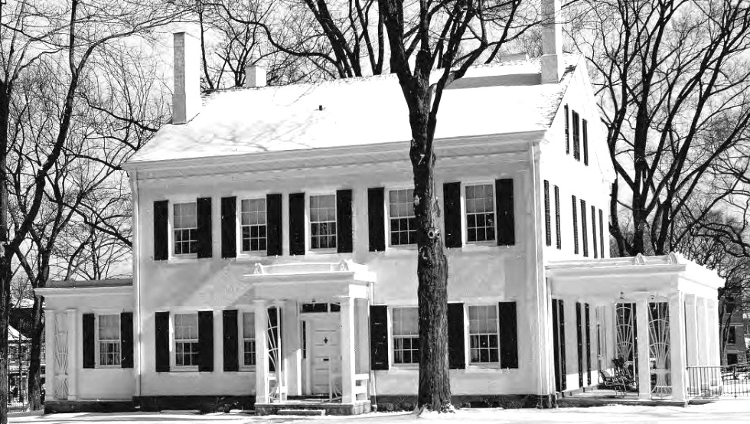
Figure 15 – Joseph Henry House at its current location – left and right porches added later

Henry’s Houses and Electromagnetism
Joseph Henry's residences entered into his experiments on electromagnetism. The house that he occupied from 1832 until 1837 was used in 1836 for a demonstration of a critical improvement in telegraphy – the use of the earth as a return path for electrical signals. While in Albany, Henry invented the sounding telegraph, two years before Samuel Morse's came up with the concept of a printing telegraph. Henry strung a single wire through the trees in front of Nassau Hall to connect his laboratory and the Library, with a remote connection to his home. He used this so-called "campus wire" to signal his wife about lunch. The return path was completed with metal plates submersed in water wells next to the Library and Philosophical Hall. Henry identifies this demonstration telegraph as the first time that a telegraph signal was sent in which the earth was used as a conductor.
Henry’s new house of 1838 similarly was used in his experiments – Here, the first known detection of radio waves occurs in 1842. This detection of radio waves occurs more than 40 years before the well known experiments of Heinrich Hertz. Henry connects a copper wire between the terne (lead and tin coating of steel) roof of his house and a metal plate submerged in a well. A short segment of the descending copper wire is routed into his study and wound in a spiral. A steel needle is placed inside of the spiral coil. Magnetizing of the steel needle following a lightning strike as far as 8 miles away is likely the result of reception of a radio wave burst produced by the strike. Henry presented his observation of lightning magnetization to the American Philosophical Society in 1842 and he reports the earlier observation again to a meeting at the Smithsonian in 1860.

Conclusion
With the discussion above, a few points can now be made assuredly. First, Henry was responsible for the influential plan that placed several buildings along a long rectangle centered on Nassau Hall, including his own home. Henry’s plan allowed for an unobstructed view of Whig and Clio Halls as seen from Nassau Street. The fact that the central Princeton campus is not cluttered with buildings is rightly credited to Joseph Henry. Second, Charles Steadman drafted the plans for Henry’s house, and had earlier designed and built a different professor’s house of a similar style. Given that the Joseph Henry House so closely resembles others that Steadman built in Princeton, including those constructed before Henry ever arrived in Princeton, argues that Steadman was involved in the design – but this is not conclusive. Lastly, the House is remarkable because of its distinguished occupant and the connection to the early history of electromagnetism, and not because of its design or designer.

Acknowledgements
Smithsonian, Dan Linke, Janet Temos, Jeff Clarke, Constance Greiff

Bibliography
Beam, J. 1933. The American Whig Society of Princeton University. Princeton: American Whig Society.
Belknap, A. B. 1835. A note written about “Lectures delivered at the close of the Junior year – by Prof. Henry.” Lecture Notes Collection, Princeton University Library, Department of Rare Books and Special Collections, Seeley G. Mudd Manuscript Library, Princeton University Archives - AC052, Box 22, Folder 5.
Board of Trustees Records: Rough Minutes, Letters, Accounts - 1838 April. Board of Trustees Records, Princeton University Archives, Department of Rare Books and Special Collections, Princeton University Library - AC120, Box 7, Folder 18.
Breese, G. and Coleman, E. E. 1986. Princeton University Land: 1752-1984. Princeton: Princeton University Press.
“Brick, Stone and Mortar: Some Facts about Princeton’s Physical Expansion – Periodic and Otherwise,” Princeton Alumni Weekly, February 20, 1931, p. 461.
Clark, R. J. "Joseph Henry House". Robert Judson Clark Papers, Princeton University Archives, Department of Rare Books and Special Collections, Princeton University Library - AC208, Box 4, Folder 92.
Clark, R. J. "Joseph Henry House". Robert Judson Clark Papers, Princeton University Archives, Department of Rare Books and Special Collections, Princeton University Library - AC208, Box 9, Folder 19.
Cooley, E. F. Diaries (1836-1839). Eli Field Cooley Papers, Manuscripts Division, Department of Rare Books and Special Collections, Princeton University Library - C0410, Box 7, Folder 5.
Coulson, T. 1950. Joseph Henry: His Life and Work. Princeton: Princeton University Press.
Egbert, D. D. 1947. The Modern Princeton. Princeton: Princeton University Press.
Finch, M. E. 1960. “The Joseph Henry House”. Manuscript.
Greiff, C. M., Gibbon, M. W., and Menzies, E. G. C. 1975. Princeton Architecture. Princeton: Princeton University Press.
Hageman, J. F. 1879. History of Princeton and Its Institutions Vol. 1. Philadelphia: J. B. Lippincott & Co.
Hageman, J. F. 1879. History of Princeton and Its Institutions Vol. 2. Philadelphia: J. B. Lippincott & Co.
Haviland, J. and Bridport, H. 1818. Builder’s Assistant. Philadelphia: John Bioren, John Haviland and Hugh Bridport. Available Online at: http://opac.newsbank.com/select/shaw/44282
Henry, J. 1837. An Image of the Design of the Joseph Henry House (Figure 3). Smithsonian Institution Archives, Record Unit 7001, Box 49, Folder 1.
Henry, J. Early Sketch of the Campus Plan. Smithsonian Institution Archives, Record Unit 7001, Box 30, Folder 10.
Historical Society of Princeton. Princeton’s Historic Sites and People. Available at: http://www.princetonhistory.org/collections/historic-sites.cfm
Hunter, C. H. 1836. A note written about “Lectures on Architecture to the Junior Class of 1836 at Nassau Hall by Prof. Joseph Henry.” Lecture Notes Collection, Princeton University Library, Department of Rare Books and Special Collections, Seeley G. Mudd Manuscript Library, Princeton University Archives - AC052, Box 22, Folder 6.
Inspector's Records 1837-1838. Inspector's Records, Princeton University Archives, Department of Rare Books and Special Collections, Princeton University Library - AC031 Box 1, Folder 9.
Inspector's Records 1838-1839. Inspector's Records, Princeton University Archives, Department of Rare Books and Special Collections, Princeton University Library - AC031 Box 1, Folder 10.
Inspector's Records 1839-1840. Inspector's Records, Princeton University Archives, Department of Rare Books and Special Collections, Princeton University Library - AC031 Box 1, Folder 11.
“Joseph Henry’s Home in Princeton, NJ” (Figure 4). 1863. Smithsonian Institution Archives Image # SIA2012-2992
Lane, W. J. 1947. Pictorial History of Princeton. Princeton: Princeton University Press.
Leitch, A. 1978. Princeton Companion. Princeton: Princeton University Press.
Levin, A. 2013. “The Master Builder”. Princeton Magazine February 2013: 60-63. Available Online at: http://issuu.com/witherspoonmediagroup/docs/finaljanfeb2013
Miller, J. 1836. A note written about "Lectures on Civil Architecture by Prof. Henry of Nassau Hall". Lecture Notes Collection, Princeton University Library, Department of Rare Books and Special Collections, Seeley G. Mudd Manuscript Library, Princeton University Archives - AC052, Box 22, Folder 8.
Moyer, A. E. 1997. Joseph Henry: The Rise of an American Scientist. Washington and London: Smithsonian Institution Press.
Norris, E. M. 1917. The Story of Princeton. Boston: Little, Brown and Company.
Office of the President Records : Jonathan Dickinson to Harold W. Dodds Subgroup, Papers 8: College Finances of 1830-1859. Office of the President Records : Jonathan Dickinson to Harold W. Dodds Subgroup, Princeton University Archives, Department of Rare Books and Special Collections, Princeton University Library - AC117, Box 25, Folder 1.
Office of the President Records : Jonathan Dickinson to Harold W. Dodds Subgroup, Papers 36: Trustee Minutes: (a) Building Committee of 1836-1847. Office of the President Records : Jonathan Dickinson to Harold W. Dodds Subgroup, Princeton University Archives, Department of Rare Books and Special Collections, Princeton University Library - AC117, Box 32, Folder 5.
Office of the Treasurer’s Records: 1838 – “Repairs for Joseph Henry”. Office of the Treasurer Records, Princeton University Library, Department of Rare Books and Special Collections, Seeley G. Mudd Manuscript Library, Princeton University Archives - AC128, Box 1, Folder 40.
Office of the Treasurer’s Records: 1835-1838. Office of the Treasurer Records, Princeton University Library, Department of Rare Books and Special Collections, Seeley G. Mudd Manuscript Library, Princeton University Archives - AC128, Box 3, Folder 4.
“Princeton and Architecture.” Princeton Alumni Weekly, April 5, 1935, pg. 1
Princeton University. An Interactive Campus History 1746-1996. Available at: http://etcweb.princeton.edu/Campus/
Reingold, N., Molella, A. P., Rothenberg, M., Waldenfels and K., Steiner, J. F. 1972. The Papers of Joseph Henry. Vol 2. Washington: Smithsonian Institution Press.
Reingold, N., Molella, A. P., Rothenberg, M., Waldenfels and K., Steiner, J. F. 1979. The Papers of Joseph Henry. Vol 3. Washington: Smithsonian Institution Press.
Reingold, N., Molella, A. P., Rothenberg, M., Waldenfels and K., Steiner, J. F. 1981. The Papers of Joseph Henry. Vol 4. Washington: Smithsonian Institution Press.
Rhinehart, R. P. 1999. The Campus Guide: Princeton University. New York: Princeton Architectural Press.
Steadman, C. 1837. "Articles of Agreement with American Whig Society to Build a Building for Them for $7000". Willard H. Bradford Princeton Collection, Manuscripts Division, Department of Rare Books and Special Collections, Princeton University Library - C0057, Box 1, Folder 27.
Trustee Minutes – September 29, 1935. Board of Trustees Minutes. Vol. 3, p.303. Princeton University Library, Department of Rare Books and Special Collections, Seeley G. Mudd Manuscript Library, Princeton University Archives - AC120. Available Online at: http://arks.princeton.edu/ark:/88435/7w62f826z
Trustee Minutes – April 12, 1936. Board of Trustees Minutes. Vol. 3, p.314. Princeton University Library, Department of Rare Books and Special Collections, Seeley G. Mudd Manuscript Library, Princeton University Archives - AC120. Available Online at: http://arks.princeton.edu/ark:/88435/7w62f826z
Trustee Minutes – September 29, 1936. Board of Trustees Minutes. Vol. 3, p.328. Princeton University Library, Department of Rare Books and Special Collections, Seeley G. Mudd Manuscript Library, Princeton University Archives - AC120. Available Online at: http://arks.princeton.edu/ark:/88435/7w62f826z
Trustee Minutes – April 11, 1937. Board of Trustees Minutes. Vol. 3, p.330. Princeton University Library, Department of Rare Books and Special Collections, Seeley G. Mudd Manuscript Library, Princeton University Archives - AC120. Available Online at: http://arks.princeton.edu/ark:/88435/7w62f826z
Trustee Minutes – April 12, 1937. Board of Trustees Minutes. Vol. 3, p.333. Princeton University Library, Department of Rare Books and Special Collections, Seeley G. Mudd Manuscript Library, Princeton University Archives - AC120. Available Online at: http://arks.princeton.edu/ark:/88435/7w62f826z
Trustee Minutes – September 26, 1937. Board of Trustees Minutes. Vol. 3, p.338. Princeton University Library, Department of Rare Books and Special Collections, Seeley G. Mudd Manuscript Library, Princeton University Archives - AC120. Available Online at: http://arks.princeton.edu/ark:/88435/7w62f826z
Trustee Minutes – April 10, 1938. Board of Trustees Minutes. Vol. 3, p.343. Princeton University Library, Department of Rare Books and Special Collections, Seeley G. Mudd Manuscript Library, Princeton University Archives - AC120. Available Online at: http://arks.princeton.edu/ark:/88435/7w62f826z
Trustee Minutes – September 26, 1938. Board of Trustees Minutes. Vol. 3, p.352. Princeton University Library, Department of Rare Books and Special Collections, Seeley G. Mudd Manuscript Library, Princeton University Archives - AC120. Available Online at: http://arks.princeton.edu/ark:/88435/7w62f826z
Wertenbaker, T. J. 1946. Princeton 1746-1896. Princeton: Princeton University Press.
Williams, B. H. 1836. A note written about "Lecture on Architecture delivered by Prof. Henry, July 1836". Lecture Notes Collection, Princeton University Library, Department of Rare Books and Special Collections, Seeley G. Mudd Manuscript Library, Princeton University Archives - AC052, Box 22, Folder 7.
Williams, J. R. 1905. The Handbook of Princeton. New York: The Grafton Press.
Note that the word ‘campus’ is latin for ‘field’. The first time that the term ‘campus’ was ever used to describe the grounds of a college was in reference to the gated field in front of Nassau Hall.

