**Developing the FabNet Electric Motor Invention Kit Sequence**

*Glen Bull, Joe Garofalo, Nigel Standish, Michael Littman, and Matthew Hoffman*

Makerspaces in schools offer new possibilities for teaching and learning. Makerspaces provide access to technologies such as 3D printers and desktop fabrication systems with accompanying design software. Makerspaces in their current form are a relatively recent phenomenon made possible by advances in technology. Many teachers in schools received no preparation in their use because affordable desktop fabrication systems did not exist when they received their licenses.

Identification of effective uses of makerspaces in school settings will require exploration and experimentation. FabNet is a fabrication network established to explore possible ways in which makerspaces might be used to support project-based learning in schools.

The members of this coalition envisioned that FabNet could serve as an incubator for development and dissemination of innovations related to makerspaces. The core FabNet design team is anchored by the Curry School of Education at the University of Virginia. Other members of the core design team include the Smithsonian Institution, Princeton University, Midland Technical College, and the Laboratory School for Advanced Manufacturing (Lab School).



*Figure 1. The core design team of the FabNet Fabrication Network*

The Lab School was established to provide a testbed for exploration of these possibilities (Bull, Haj-Hariri, Atkins & Moran, 2015). The Lab School consists of three linked makerspaces: the Buford Engineering Design Academy in the Charlottesville City Schools, the Sutherland Engineering Design Academy in the Albemarle County Public Schools, and the K-12 Engineering Design Laboratory in the Curry School of Education at the University of Virginia. The middle school sites are run by their respective school systems (Charlottesville and Albemarle). These sites are supported by the University’s K-12 Engineering Design Laboratory.

Members of the FabNet network have collaborated on development of hardware (such as development of an enclosed 3D printer with a HEPA filter to remove nanoparticles emitted by the printer) and software (such as development of a computer-assisted design program for elementary and middle-school students).

One major initiative undertaken by the FabNet coalition involves use of makerspaces to reconstruct historic inventions such as the telephone, the telegraph, and early electric motors. The historic reconstruction project, *American Innovations in an Age of Discovery*, explores the principles that underlie key inventions, as well as connections between inventions and the way in which one invention led to another.

A planned sequence of connected inventions was identified. These include inventions that underlie the telegraph system, the telephone system, the electrical power grid, and radio, among others. A series of FabNet Invention Kits is being developed that allows students to use makerspaces to reconstruct working models of these inventions.

The FabNet Invention Kits provide resources that include: (1) a scanned 3D image of the invention, (2) a CAD model of the invention, (3) animations that depict its operation, (4) related historical resources including patents and descriptions from inventors’ notebooks, (5) instructional guides for teachers, (6) resources for students, (7) assessment items, and (8) accompanying professional development materials (Bull, Standish, Johnson, Haj-Hariri, 2016).

**Motivation for the FabNet Invention Kit Project**

The motivation for development of historical reconstruction kits, undertaken in collaboration with the Smithsonian Institution, is two-fold.

1. One motivation is to fulfill the mission of the National Museum of American History by helping “people understand the past in order to make sense of the present and shape a more humane future” (Mission and History, n.d).

In this instance, reconstruction of historic inventions provides a lens to understand the way in which the United States became the nation that it is today, and implications for the future.

1. A second motivation is to allow students to understand the science and engineering principles that underlie transformational inventions.

The pedagogical foundation for this work is grounded in the framework for a Princeton course, *Engineering in the Modern World* developed by David Billington and Michael Littman (Course Offerings, 2015). The premise of the course is that foundational inventions such as the telephone, the telegraph, and nineteenth century relays are transparent. For example, all of the parts in a nineteenth century telegraph can be observed. Hence its operation is more accessible to learners than a modern-day solid state relay (Billington & Billington, 2013).

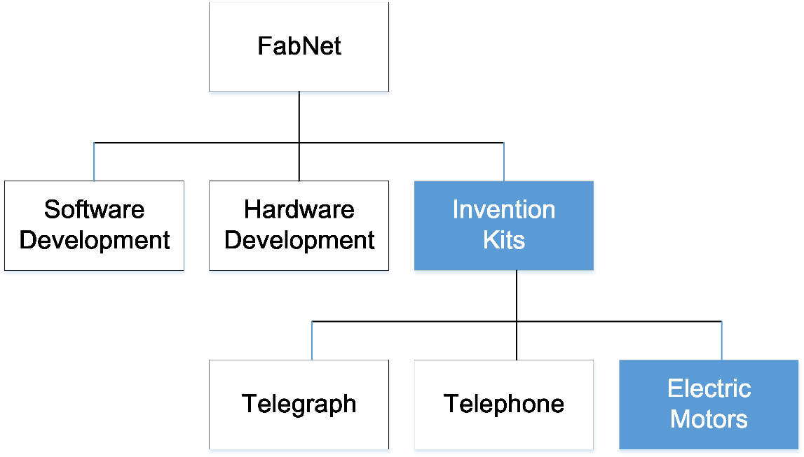

*Figure 2. FabNet Collaborative Activities*

**Roles of Key Participants**

The members of the core design team, including principal investigators from the Smithsonian, Princeton, Midland Technical College, and the Curry School of Education at the University of Virginia, participate in a standing planning and development meeting each week. The principal investigator at the Smithsonian, Matthew Hoffman, is the Director of Digital Learning at the National Museum of American History. He serves as liaison with the curators of the electricity and magnetism collection and the physics collection, coordinates collaborative efforts with the Smithsonian 3D Digitization Office, oversees dissemination of project materials on the Smithsonian 3D web site (<http://3D.si.edu>), provides coordination with the Smithsonian Enterprises office, and serves as a point of contact with other Smithsonian museums such as the National Air and Space Museum.

The principal investigator at Princeton, Michael Littman, is a professor of engineering and principal investigator of the Joseph Henry Apparatus Project. (Joseph Henry was a professor at Princeton who later served as the first secretary of the Smithsonian.) In that role, he provides expertise related to science and engineering education, with a particular emphasis on historical reconstruction of inventions, piloted in his course, Engineering in the Modern World. The principal investigator at Midland Technical College, Alan Grier, is the director of the Midland Machine Tools Program. In that role, he provides expertise on connections between historical inventions and modern day applications.

The principal investigator at the Curry School of Education, Glen Bull, provides coordination with the Laboratory School for Advanced Manufacturing and with other schools serving as test sites. He also provides coordination with the K-12 Engineering Design Laboratory at the University of Virginia directed by Joe Garofalo, another Curry School faculty member. The Curry School’s Engineering Design Laboratory develops prototypes of FabNet Invention Kits, develops accompanying K-12 instructional materials, develops associated assessment items, provides professional development for teachers, and conducts an annual K-12 Engineering Design Academy each summer.

To support the FabNet Invention Kit initiative, an advisory board was established that includes representatives from the National Academy of Engineering, the Association of Science Teacher Educators (ASTE), the Association of Mathematics Teacher Educators (AMTE), the International Technology and Engineering Education Association (ITEEA), the Association for Educational Communications and Technology (AECT), and the Society for Information Technology and Teacher Education (SITE), among others. The members of the advisory board review materials throughout the year as they are developed. They also participate in an annual advisory board meeting at the Smithsonian each year.

**The Electric Motor Sequence**

This design case describes ways in which a series of FabNet Invention Kits tracing the invention and evolution of the electric motor were developed. We began with an electric motor patented by Thomas Davenport in 1837. This was the first U.S. Patent (U.S. Patent No. 132, 1837) awarded for invention of an electrical device. It therefore occupies a foundational place in history.

**Science Objectives for the Electric Motor Sequence**

During the time frame that work leading to establishment of the Lab School took place, there was a three-year effort (2011 – 2013) to develop next generation science standards (NGSS) in the United States (NGSS Lead States, 2013). Many stakeholders were involved in development of a framework to integrate engineering into science to promote interdisciplinary inquiry and applied practice of core ideas. One of these standards (MS-PS2-3) involves electric motors and generators.

**MS-PS2-3. Ask questions about data to determine the factors that affect the strength of electric and magnetic forces.**

Clarification Statement: Examples of devices that use electric and magnetic forces could include electromagnets, electric motors, or generators. Examples of data could include the effect of the number of turns of wire on the strength of an electromagnet, or the effect of increasing the number or strength of magnets on the speed of an electric motor.

*Assessment Boundary: Assessment about questions that require quantitative answers is limited to proportional reasoning and algebraic thinking.*

This NGSS standard provided a context for connecting national science and engineering standards to use of school makerspaces for reconstruction of historic electric motors.

**Engineering Objectives for the Electric Motor Sequence**

The K-12 students needed technical skills that encompass mechanical engineering, electrical engineering, and computer science in order reconstruct historic inventions using modern technologies. The field of mechatronics integrates all three disciplines.

From a historical perspective, these three disciplines correspond to three epochs of innovation that were identified through the project: (1) the electromechanical age (1840 – 1920), which began with invention of the telegraph, (2) the electronic age (1920 – 1960), which began with invention of the vacuum tube, and (3) the computer age (1960 – 2000) which was made possible by the electronic age. These three eras culminated in the current age of making.

**Pedagogical Considerations related to the Electric Motor Sequence**

Extensive efforts have documented limitations in the traditional way in which students learn science concepts, including concepts related to electricity and magnetism. A series of documentaries supported by the National Science Foundation revealed the extent to which college graduates lack understanding of basic concepts found in elementary and middle school science standards.

For example, in one documentary, *Minds of Our Own*, M.I.T. graduates are asked if they can light a bulb with a battery and a wire. Each graduate confidently asserted that they would be able to do this. However, almost all of the engineering students were unable to accomplish the task. They were perplexed by their inability to light the bulb. One graduate concluded, “Well I am a mechanical engineer and not an electrical engineer” (Minds of Our Own, 1997).

The investigator for the *Minds of Our Own* documentary, Philip Sadler (Minds of Our Own, 1997), notes that all of the participants predicted that they would be able to light a bulb with a battery even though most could not. The graduates of one of the preeminent engineering institutions in the U.S. were unable to complete an elementary school competency. If the foundational concepts that underlie this competency are not understood, related concepts that build on this foundation cannot be understood.

The documentary and its companion, A *Private Universe* (1994), contributed to the impetus for educational reforms. These reforms focused on inquiry rather than instructional methods that emphasize “memory at the expense of critical thought, bits and pieces of information instead of understandings in context, recitation over argument, and reading rather than doing” (Nelson, 1998, p. 42).

Makerspaces in schools can potentially support hands-on science and engineering activities that encourage inquiry. Members of the FabNet coalition collaborated on a number of activities and projects designed to facilitate this type of project-based activity. This design case focuses specifically on efforts to develop a scaffolded sequence of activities to support reconstruction of electric motors.

**Phase 1. Reconstructing the Davenport Rotary Motor**

We began development of an Electric Motor Invention Kit sequence with an effort to reconstruct the Davenport rotary motor. The decision was made to begin with this invention because it was the first electric motor patented in the U.S.

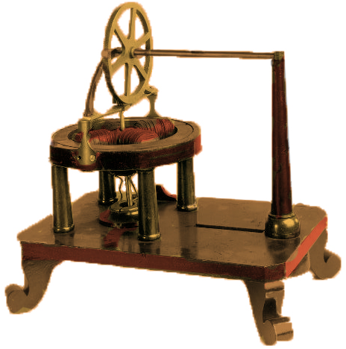

*Figure 2. The Davenport Rotary Motor (U.S. Patent #132).*

**Replicating an Experiment with an Expert Panel (2014)**

The advisory board initially met at the 2014 National Technology Leadership Summit ([www.ntls.info](http://www.ntls.info)). To establish a baseline, we conducted a variation of the experiment conducted in the documentary, *Minds of Our Own* (Minds of Our Own, 1997). Members of the advisory board were invited to participate in development of a challenge involving design and construction of an electric motor using equipment commonly found in school makerspaces. The final version of the design challenge was distributed to the members of the panel one month prior to the advisory board meeting. The participants were given an advance copy of the challenge so that they could undertake any preparations that they believed might be needed.

At the advisory board meeting, members of the panel were asked to work in teams to design and fabricate a rotary motor. Each team was provided with a 3D printer, a computer-controlled die cutter, magnets, magnet wire, batteries, hand tools, and other supplies and equipment that might be needed to fabricate an electric motor.

Although this type of electric motor is more complex than the “battery – bulb – wire” circuit featured in *Minds of Our Own*, the members of the panel expressed confidence in their ability to achieve the goal. The representative from the National Academy of Engineering said that the task would not be useful as a basis for discussion because it was trivial and “could be completed in fifteen minutes” (personal communication, September, 2013). We still felt that it would be worthwhile to ask the experts to attempt the same task that we planned to use as the basis for K-12 student activities.

The results were similar to those highlighted in the *Minds of Our Own* documentary. None of the teams was successful in designing or fabricating a working electric motor. At the end of the day, Michael Spector – past president of AECT and current editor of *Educational Technology, Research and Development* – summarized the result, commenting, “Today I learned that not only am I not able to make an electric motor, I don’t even understand how one works” (personal communication, September, 2013).

This exercise was useful because it created cognitive dissonance between the belief of the advisory board members that they could construct a working electric motor and their demonstrated inability to perform the task. It was useful in establishing an understanding of the challenge that this task might present to a middle school student.

**Replicating an Experiment with Teachers**

The Lab School teachers were given release time to allow them to develop curricular activities that made use of makerspaces established to support their work. Selected teachers at one of the two Lab School sites (one in Charlottesville and one in Albemarle) were placed on eleven-month contracts to allow them time to collaborate on the project. STEM teachers at the other site were also given several weeks of release time. A summer engineering academy staffed by faculty and graduate students at the University was held for the teachers and selected K-12 students in support of this effort.

The experiment conducted with the advisory board panel was repeated with the teachers, with the same result. The participating teachers had taught units on electricity and magnetism in their classes. They were confident that they understood how an electric motor worked, and believed that they could use this knowledge to build a working model of an electric motor.

This belief was challenged when they attempted to design and fabricate a motor. One teacher commented, “I didn’t know that I didn’t understand how an electric motor works. And if I didn’t understand it, think how much less the students must have learned” (personal communication, June, 2014).  The illusion of greater understanding than exists is widespread. As noted above, it was documented in the video, *Minds of Our Own*, and again in the beliefs of the expert panel that served as an advisory board for this project. It also proved to be frequently encountered in the participating middle school science teachers who teach these subjects.

Rosenblat and Kiel use the term *illusion of explanatory depth* to describe the phenomenon, reporting that “People feel they understand complex phenomena with far greater precision, coherence, and depth than they really do; they are subject to an illusion—an illusion of explanatory depth. The illusion is far stronger for explanatory knowledge than many other kinds of knowledge, such as that for facts, procedures or narratives.” (Rozenblit & Keil,2002, 521)

After working for much of the summer, one of the six teachers did succeed in fabricating a working electric motor. Sparks and smoke streamed from the motor as it rotated, but the process proved useful in allowing the teacher to unpack and assimilate key concepts involved in its operation.

The teachers were not, however, successful in developing a design that could be replicated and shared for use in makerspaces at other schools. The number of skills required exceeded their capacity to succeed in this goal. These elements involved mastery of computer assisted design (CAD) software, digital fabrication, electronics, mechanical skills, material science, and engineering design, among others. Nothing in their educational background had prepared them for this task.

Further, although all of the teachers had originally volunteered to participate in the project, several of them later expressed skepticism about the goals of the project. Although both superintendents of the participating school systems had indicated that the teachers would not be evaluated on the basis of student performance on high stakes tests (which in Virginia are known as the “Standards of Learning” or SOLs), this was still very much on their minds.

These teachers, perhaps not without justification, felt that the goals of the project were not practical in the context of the other classroom content that was required. To provide context for this, the pacing guide called for all of electricity and magnetism to be covered in approximately four class periods. The science teachers who taught this content had no background in engineering. Several of them did not see it as relevant to their instructional methods or goals. The teachers’ perspective was echoed nationally by at least some science educators who prepare science teachers.

This does not imply that no science teachers may be able to use makerspaces to develop designs that can be replicated at other schools. Science teachers such as Bruce Yeany (2006), author of *If You Build It, They Will Learn* (cite), are clearly capable of doing this. It did prove to be the case, however, that the teachers participating in this initiative did not develop a design that could be disseminated to other schools.

**Developing a Reference Design for a Rotary Motor**

*Decision Point 1.* Because the teachers were not successful in designing a reliable reconstruction of the Davenport rotary motor that could be replicated, a decision was made to develop a reference design in the K-12 Engineering Design Laboratory. To move the project forward, faculty and graduate students in the at the University of Virginia designed a prototype for a rotary motor. The prototype rotary motor worked well from a mechanical perspective. However, the switching mechanism, known as a *commutator*, still proved to be challenging and difficult for students to understand.

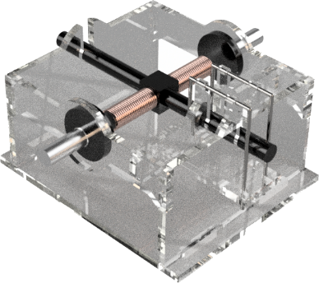 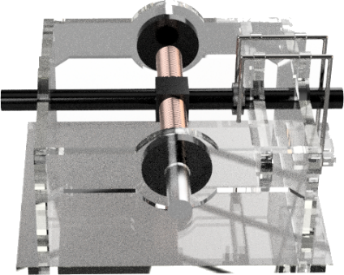

*Figure 3. Prototype for a Rotary Motor – oblique view (left) and side view (right)*

As a historical footnote, design of the commutator also proved to be challenging for the original inventor, Thomas Davenport. After working on the project for more than a year, he exclaimed, “There is no power on earth that can cause this to rotate more than half a turn!” A letter written by Davenport’s brother explains that the design for a working commutator was eventually developed by Davenport’s wife, Emily. (Stanley, 1993; Vare, 2003)

This vignette illustrates that the aspects that were difficult for the original inventors are also ones that are likely to prove challenging for modern-day explorers who attempt to retrace the inventors’ footsteps. Students who study the historic record often find these parallels to be reassuring. If iconic figures in history experienced these difficulties and were discouraged and frustrated at times, it is not unreasonable that a middle school student might experience the same difficulties. This knowledge can enable students to persist rather than quitting after the first failure that they experience. This, in itself, was one of the more significant outcomes.

Students encountered two difficulties also faced by the original inventors:

1. *Conceptual Difficulties*.

The students had difficulty understanding the principles underlying the commutator of a rotary motor.

1. *Mechanical Difficulties*.

It was mechanically challenging for students to construct the mechanism of the commutator. There is a narrow tolerance which makes it difficult to construct a reliable commutator.

*Decision Point 2*. These difficulties that the students encountered led to a decision to develop a second FabNet Invention Kit to precede the rotary motor kit. This led to reconstruction of a motor with a switching mechanism that was easier to understand and reconstruct.

**Phase 2. Reconstructing the Charles Page Motor**

The Charles Page linear motor (U.S. Patent No. 10480A, 1854). shuttles an armature back and forth between two solenoids, one on the left and one on the right. A switching mechanism in a flywheel alternately turns on the left and right solenoid to move the armature back and forth as the flywheel turns. Because there is a discrete point at which the armature reverses direction, the mechanism is easier to observe and understand than a rotary motor.

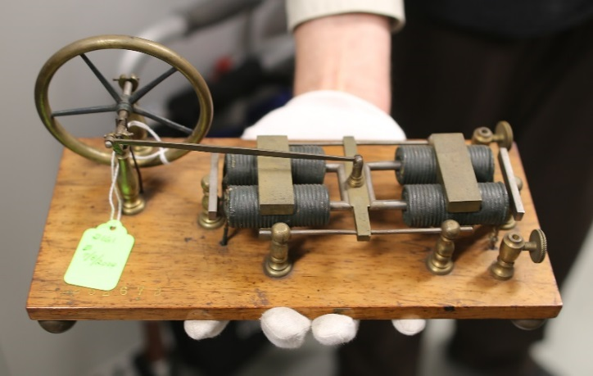

*Figure 4. The Charles Page Motor (1854)*

The switching mechanism for the Charles Page linear motor also requires less mechanical dexterity and finesse to construct successfully.

**Developing a Reference Design for the Charles Page Motor**

Faculty and staff in the K-12 Design Lab at the University of Virginia developed a reference design for reconstruction of the Charles Page engine. The lead designer, Nigel Standish, developed a prototype that was intended to be a modern-day reconstruction that made use of today’s digital fabrication tools rather than creating an exact replica of the mechanism. This simplified the design and made it easier to understand and construct while illuminating the underlying principles of operation. The core FabNet design team conducted weekly videoconferences to review and critique the design as it was developed.

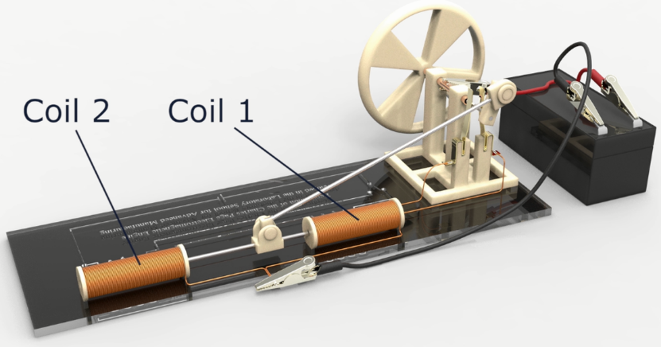

*Figure 5. Reconstruction of the Charles Page Motor*

The completed design proved to be one that students in the middle school could successfully reconstruct. We originally intended this design to serve as a point of reference for students, serving as a proof-of-concept that would allow them to construct their own variations. This strategy would have produced a range of models illustrating the many different ways that a design challenge could be approached.

However, several factors made development of variants of the reference design impractical in the Lab School setting where the FabNet Invention Kits were piloted. The students did not have sufficient expertise to undertake this task. They lacked applied experience and conceptual understanding at this stage. Moreover, they did not have sufficient time to make this exercise practical.

The FabNet design team included engineers, science educators, cultural anthropologists, and curators at the Smithsonian. This was the full-time focus of the work for several members of the team. Even with scaffolding, development of variants of the reference design in a school setting could not be accomplished with the time and resources available.

**Implementation in a School Setting**

Our original plan involved a two-step sequence: (1) students in engineering class would design and fabricate electric motors. (2) These motors would then be used as the basis of instruction for related concepts in science class. The teachers had previously used a commercial demonstration model to introduce electric motors in physical science classes.

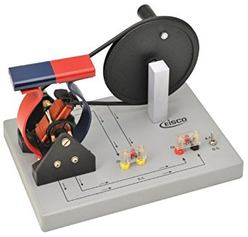

*Figure 6. The Commercial (Eisco) Demonstration Motor / Generator*

We thought that the activity might be more engaging and meaningful if the science demonstration apparatus was fabricated by the students themselves. While the pacing guide did not provide time to construct the electric motors in science class, working models had been fabricated in middle school engineering class. This made it more practical to integrate locally fabricated motors into science class activities. At one of the Lab School sites, the science teachers did successfully incorporate the motors fabricated in engineering class into their science classes. They experienced good success in this approach reporting that their students achieved a deeper understanding of the concepts.

At the other Lab School site, the science teachers elected not to use the motors fabricated by their students in engineering class. Although these science teachers had originally volunteered for the project, they did not see a strong connection with the science standards that they taught. Consequently, they were less enthusiastic about participation. The result was very little integration into their science classes.

**Repeating the Advisory Board Experiment (2015)**

For the 2015 meeting of the project advisory board, we arranged for six Lab School students to serve as mentors to the members of the advisory board. In contrast to the year before, all of the teams of advisory board members were able to successfully fabricate a working motor. Several of them had approached the task with some trepidation given the difficulty encountered the year before. Several variables had changed: (1) in contrast to the previous year, teams were provided with a prototype reference design, (2) the design for the linear motor was not as complex as the design required for the rotary motor, and (3) each team was supported by a middle school student who had successfully completed the design. Despite the provision of a reference design and simplification of the design challenge, advisory board members uniformly focused on the presence of a student mentor as the reason for their success. They also found it helpful to talk directly with the students about their school experiences.

The four teams consisted of (1) engineering educators, (2) science educators, (3) educational technology specialists, and (4) generalists. Although all four teams successfully completed a working motor, several members of the science education team elected not to participate. One science educator was philosophically opposed to inclusion of technology in science teaching, with several peer-reviewed publications on this topic. This individual also felt that there was not sufficient time to cover the mandated science topics, and therefore opposed introduction of engineering content into science courses. This view was consistent with the opinions of some of the Lab School science teachers. Another science educator indicated that since their area of expertise was in chemistry rather than physics education, they felt that they would be unable to contribute meaningfully. In some ways, this echoed the perspective of the M.I.T. graduates who noted that their field was mechanical engineering and not electrical engineering.

Development of the Charles Page Invention Kit was a significant step forward. It proved to be practical to implement in middle school engineering classes. This switching mechanism is less abstract and more easily constructed than the commutator in the Davenport rotary motor. However, it does introduce a point of mechanical complexity.

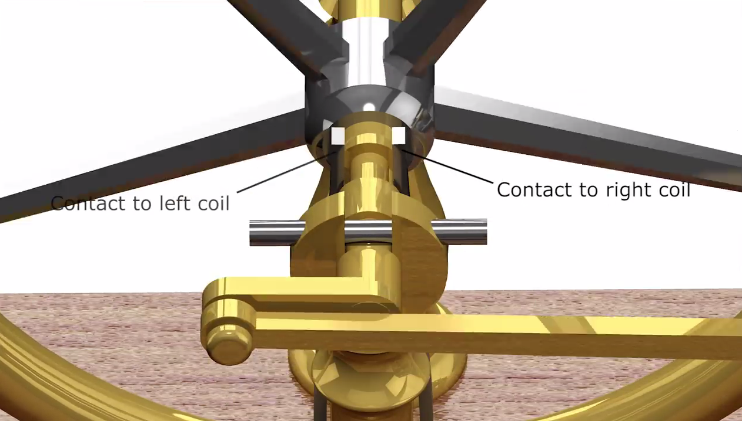

*Figure 7. Charles Page Motor: Switching Contacts*

A rotating contact on the axle of the flywheel in the Charles Page motor serves to switch current between two solenoids. Each solenoid when energized draws the armature inward. The armature is connected to the flywheel via a crank. The crank serves to rotate the flywheel. The flywheel stores rotational energy and smooths out the motion so that angular velocity is relatively constant in time. The switching contacts can spark and corrode if they are not adjusted properly. These issues increase the amount of time that is required for a novice to reconstruct the Charles Page motor.

*Decision Point 3*. Consequently, a decision was made to use the Charles Page reference design as the starting point for development of a third design with less complexity, in order to make the foundation concepts even more accessible.

**Phase 3: A Contemporary Linear Motor**

The goals for the third design were two-fold: development of a design that less complex and therefore (1) conceptually easier to understand, and (2) easier to construct from a mechanical perspective.

**Developing a Reference Design for a Contemporary Linear Motor**

The members of the K-12 Engineering Design Laboratory simplified the design by replacing the iron armature (a temporary magnet) with a permanent magnet. Since the permanent magnet has a north and south pole, the two solenoids of the Charles Page engine can be replaced with a single solenoid.

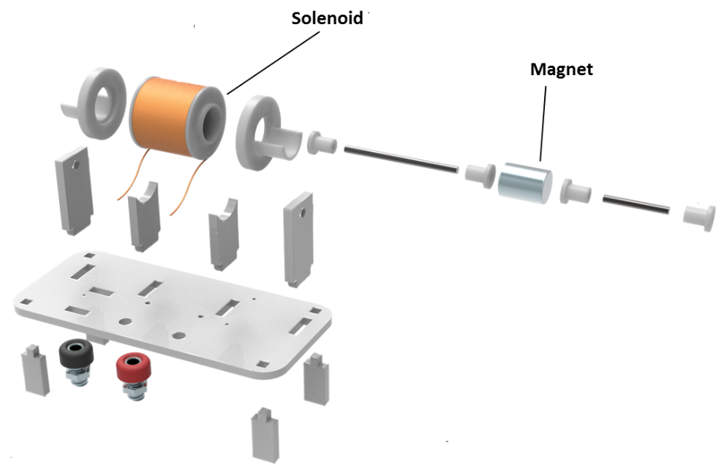

*Figure 8. Contemporary Linear Motor (Exploded View)*

When an alternating current is sent to the solenoid, the magnet moves in one direction when the voltage is positive, and moves in the opposite direction when the voltage is negative. The contemporary linear motor, therefore, is an alternating current (AC) motor. This feature makes it possible to eliminate the switching mechanism and flywheel. This simplification of the design allowed students to quickly and reliably construct a working motor. Because there are fewer working parts, the design is easier to understand, and is also easier to construct.

One of the goals of the project was to build capacity to allow students to create innovations and inventions of their own design. The contemporary version of the linear motor removed the complexity of the flywheel and switching mechanism by employing an external alternating signal. This simplifies construction. The time saved through this approach was used to allow students to incorporate the linear motor into other mechanisms.

**Replicating an Experiment with an Expert Panel (2016)**

This contemporary linear motor was used as the basis for the third annual meeting of the advisory board. In this implementation, the advisory board members were able to successfully collaborate with their student mentors to construct a linear motor and use it to operate an animatronic mechanism.

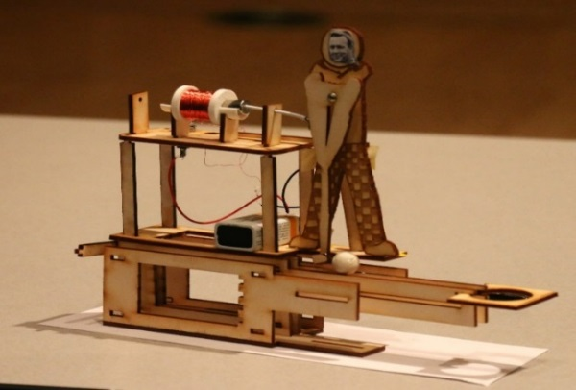

*Figure 9. Mechanism Constructed with a Linear Motor*

The success experienced in the previous year’s advisory board meeting in 2015 provided a foundation for the 2016 meeting. By this time, the advisory board members were accustomed to collaborating with Lab School students, using them as advisors and informants as they participated in the activity. In contrast to the previous year, all of the advisory board members participated, including the science education representatives. The teams Lab School students and the advisory board members were successful in designing and constructing a series of animated figures (Bull, Schmidt-Crawford, McKenna, Cohoon, In Review) powered by the linear motor, such as a golfer powered by the linear motor (Figure 9),

**An Ecological System of Tools**

Because the contemporary version of the linear motor is an AC motor, powered by alternating current, a mechanism is required to reverse the current. Joseph Henry, the first secretary of the Smithsonian, developed a mechanism that he described as a “pole reverser” that will accomplish this.

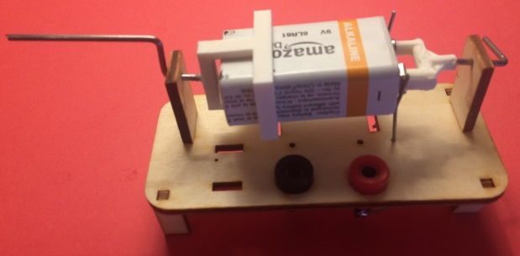

*Figure 10. Battery Alternator (Reverses Polarity)*

To scaffold the concept, we developed a battery alternator (Figure 10). As the battery rotates, the magnet reverses direction with each half turn of the battery, as the voltage alternates between positive and negative.

Once the concept of alternating current is introduced by this means, a pole-reversing switch modeled on the circuit developed by Joseph Henry is introduced (Figure 11).

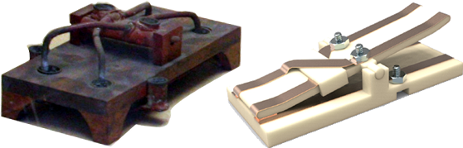

*Figure 11. Joseph Henry Pole-Reversing Switch (left) and Reconstruction (right)*

This, in turn, provides scaffolding for the concept of a waveform generator. An online waveform generator was developed to support the project (Figure 12). The waveform generator allows students to use a computer, tablet, or smartphone to generate an alternating current that can be adjusted to a frequency that ranges from 1 Hz to 1,000 Hz in one Hz increments.

That allows students to move the linear motor back and forth at a corresponding rate. Once the rate of movement exceeds 60 Hz, the movement of the motor is heard as an audible tone. This provides scaffolding for subsequent understanding of the speaker used in the Telephone Invention Kit.

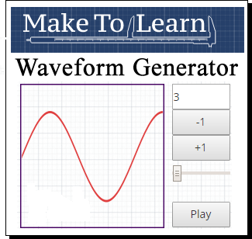

*Figure 12. An online waveform generator developed for use with the linear motor*

The contemporary linear motor and the waveform generator developed to accompany provides scaffolding for introduction of the topic of waveforms. This will eventually provide scaffolding for an introduction to the topic of computer-controlled motors.

**Implementation in Elementary Grades**

The simplified version of the linear motor was also piloted with a group of fourth and fifth grade students. The students in this elementary school had previously participated in activities in language arts and social studies involving construction of dioramas. The linear motor was used to power animated figures in the diorama.

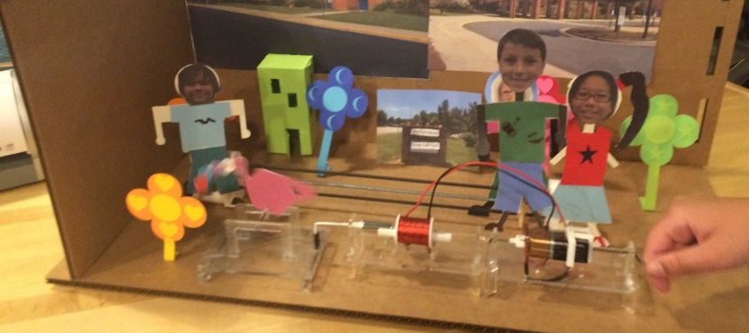

*Figure 13. Diorama Constructed with Linear Motor and Battery Alternator*

For example, in the diorama shown above (Figure 13), the linear motor is moving a pink watering can that is watering a yellow flower. The student is turning the battery alternator to move the motor back and forth. The success of this activity demonstrated that with proper scaffolding, even students in the upper elementary grades are capable of using the linear motor as a springboard for inventions and creations of their own devising.

**Prerequisite Knowledge: Solenoid Invention Kit**

Solenoids are at the heart of all three motors, including: (1) the Davenport motor (1837), (2) the Charles Page motor (1857), and (3) the contemporary linear motor (designed in 2016). In order to help students understand the connections and elements common to all three types of motors, a Solenoid Invention Kit was developed to introduce prerequisite knowledge.

Ampere’s research with the solenoid led to development of Ampere’s Law in the nineteenth century. Ampere’s law describes the relationship between current and magnetic field and it allows one to determine the magnetic field strength in and around solenoids of various shapes and sizes. This information was useful to subsequent inventors who developed electromechanical inventions. The same knowledge is useful to modern-day explorers retracing the footsteps of the original pioneers.

Related assessment items were devised to assess the students’ understanding of concepts involving electricity and magnetism after completion of the Solenoid Invention Kit activities. The students demonstrated little or no understanding of these concepts on a pre-test. After the Solenoid Invention Kit was implemented in an initial pilot, approximately one-third of the students demonstrated a good or deep understanding of the underlying concepts on the post-test. The student responses on the post-test were analyzed through qualitative analysis and used to identify misconceptions. This information was used to revise the materials to address misconceptions that persisted after completion of an initial pilot of the Solenoid Invention Kit.

After revision of the Solenoid Invention Kit based on this analysis, a second implementation was conducted in the following school year. The results on the pretest were comparable to those of the initial implementation of the Solenoid Invention Kit. However, on the post-test after completion of the Solenoid Invention Kit activities, nearly 90 percent of the students demonstrated a good or excellent understanding of foundational concepts related to electricity and magnetism.

A longitudinal study will be used to track the extent to which students retain these concepts over time. The gains in student understanding achieved demonstrate that even when a student can successfully build a mechanism, this does not necessarily mean that they understand how it works. Therefore, the hands-on project must be supplemented by additional assessment to determine the extent to which understanding is achieved.

`

**The Electric Motor Sequence**

The activities described were implemented through a process of successive approximation over a period of several years.

2013 Laboratory School for Advanced Manufacturing Established

2014 Davenport Motor Reconstructed

2015 Charles Page Motor Reconstructed

2016 Contemporary Linear Motor Designed

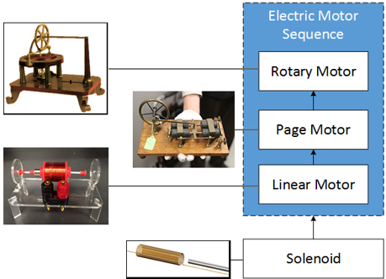

*Figure 14. The Electric Motor Instructional Sequence*

In the sequence developed to date (Figure 14), the solenoid provides scaffolding for the contemporary linear motor. This linear motor, in turn, provides scaffolding for reconstruction of the Charles Page Motor (1854). This motor, in turn, provides scaffolding for the original Davenport Rotary Motor, awarded the first U.S. patent for an electrical device in 1837. The design process involved reverse engineering more complex mechanisms to create a sequence in which foundational concepts are introduced through relatively simple mechanisms, which provide scaffolding for more complex foundational designs.

The end result was a sequence of Invention Kits that provide scaffolding for a series of mechanisms that are increasingly complex and mechanically sophisticated. The Solenoid Invention Kit introduces foundational concepts related to electricity and magnetism. The contemporary Linear Motor Invention Kit provides an introduction to switching mechanisms, including the battery alternator and the Joseph Henry pole-reversing device. The Charles Page Invention Kit introduces use of a flywheel and rotating contact to switch between two solenoids as a means of driving the motor. The series culminates in the Davenport Rotary Motor which introduces the mechanically complex and conceptually abstract idea of a commutator incorporated into the motor as a means of alternating the polarity of the current.

|  |  |  |  |
| --- | --- | --- | --- |
| **Electric Motor Invention Kit Sequence** | | | |
| *Level* | *Mechanism* | *Key Concepts* | *Dates* |
| 1. Novice | Solenoid | E & Concepts | Age of Discovery: 1820 |
| 1. Basic | Contemporary Linear Motor | Switching Contacts | Age of Making: 21st Century |
| 1. Intermediate | Charles Page Motor | Flywheel | Electromechanical Age (1854) |
| 1. Advanced | Davenport Rotary Motor | Commutator | Electromechanical Age (1837) |
| 1. Applied | Modern-day Applications | Integration | Age of Making: 21st Century |

The electric motor sequence culminates in connections to modern day applications. Manufacturing output is greater than any time in the nation’s history, and is the largest economic sector, accounting for 60 percent of the economy. Yet few science teachers understand how solenoids and electric motors are manufactured today, or how these mechanism are employed. The FabNet coalition recruited a historic manufacturer of solenoids to assist in making these connections once students understand the underlying scientific principles.

**Modern-day Applications**

One of the goals of the project is to connect the past to the present, allowing students to understand the processes through which electric motors and solenoids are manufactured today and the ways in which they are used. Sag Harbor Industries is a manufacturer of solenoids and motors. The firm was founded by the son of Thomas Edison, Charles Edison. Charles Edison had served as president of his father’s company, Thomas A. Edison, Inc., prior to founding Sag Harbor Industries. Sag Harbor Industries then served as a supplier of solenoids to Thomas A. Edison, Inc. and other firms.

Paul Scheerer, Charles Edison’s partner, later purchased Edison’s shares in the firm. Paul Scheerer, now 87, is still active in operation of the company. The firm has a number of connections to American history. For example, it was involved in manufacturing solenoids used in the first trip to the moon. Solenoids designed by the chief engineer, Bud Cecire, are in the lunar lander that still rests on the moon.

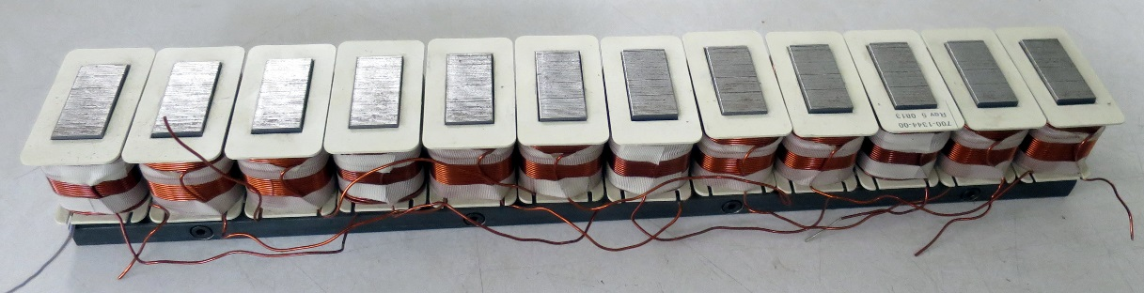

*Figure 12. Linear Motor Manufactured by Sag Harbor Industries for a Theme Park Ride*

The company is still manufacturing solenoids that are used in space flight today, as well as a range of other solenoids and electric motors for uses that range from instruments for measurement of voltages in high power electrical lines to magnetic levitation systems used in theme park rides (Figure 12).

The engineers at the firm provide a tangible connection regarding the way in which manufacturing evolved over time to the current practices today. Students often do not have an opportunity to understand the way in which knowledge that they acquire is used in industry. Participation by Sag Harbor Industries in the FabNet network provides a window on this practice.

**Dissemination**

We have not yet achieved our original vision of establishing a network of linked makerspaces that allow teachers and students to invent and share designs across schools. However, we have established the foundation for this. We have shared the resources described above on a public web site, *Make to Learn* ([www.maketolearn.org](http://www.maketolearn.org)), developed for dissemination of the materials and activities (Figure 13).

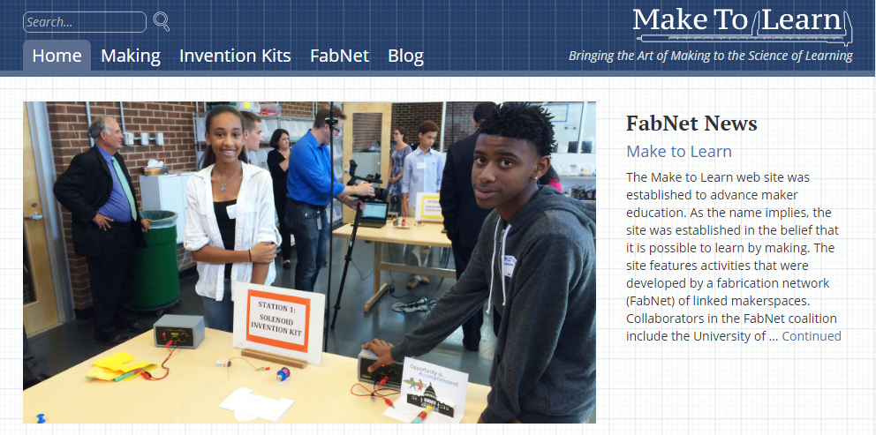

*Figure 13. Make to Learn Web Site (www.maketolearn.org)*

In order to evaluate the extent to which the activities developed by the core design team in the original fabrication network (FabNet) can be successfully implemented by teachers and students at other schools, we are currently collaborating with an extended network of test schools at other geographic locations, including teachers in schools collaborating with faculty at James Madison University (JMU), schools collaborating with the Tuscarora Intermediate Resource Unit in Pennsylvania, and schools collaborating with faculty at the University of North Texas. This will allow us to identify issues that they may encounter as they implement the activities described.



*Figure 14. Network of Test Sites*

At the same time, we have made these resources publicly available so that early adopters at other sites can make use of them as we continue to develop this sequence of activities. Some of the same activities have also been piloted in the Motor Controls Class at Midland Technical College, where they have proven useful in making the same concepts accessible to adult learners. Thus, at the present time, these resources have been successfully repurposed for use from upper elementary through community college courses.

**The Development Cycle**

Our original goal was to allow students to reconstruct historic inventions using makerspace technologies. To achieve this goal, a process of reverse engineering was used to develop a scaffolded series of activities that ultimately became the Electric Motor Invention Kit sequence. The following development cycle was employed:

* Summer – Analyze Invention and Develop Prototype for Reconstruction
* Fall – Pilot Initial Prototype in the Laboratory School for Advanced Manufacturing
* Semester Break – Analyze Results (i.e., misconceptions) and Revise Materials
* Spring – Second Implementation in the Laboratory School for Advanced Manufacturing

Three major decision points occurred during this process of reverse engineering.

*Decision Point 1.* The first decision point occurred with the realization that the teachers themselves did not have the time, resources, or expertise to develop a replicable design for reconstruction of the Davenport rotary motor.

*Response 1.* This led to the decision to develop a reference model for reconstruction of the Davenport Motor in the University’s K-12 Engineering Design Laboratory.

*Decision Point 2.* The second decision point occurred with the realization that the Davenport rotary motor was too difficult for middle school students to reliably reconstruct, even with a reference design as a guide, due to the complexity of the commutator.

*Response 2.* This led to the decision to develop a reference model for reconstruction of the Charles Page linear motor, which had a simpler switching mechanism.

*Decision Point 3.* The third decision point occurred with the realization that, while students could reliably reconstruct the Charles Page motor, additional scaffolding would greater depth of understanding of the underlying principles of operation.

*Response 3*. This led to the decision to develop a modern contemporary linear motor to provide scaffolding for introduction of the Charles Page motor. This design eliminated the switching mechanism and flywheel altogether, and proved to be more robust and simpler to construct.

The time saved in reconstruction of the contemporary linear motor made it possible to integrate the mechanism into a variety of inventions of the students’ own devising, which resulted in greater student engagement and understanding. Because of the nature of the development cycle and the related rhythm of the K-12 school year, broken into academic semester, each of the three cycles described above took one year. Including a year of pilot work preceding the project, the entire development process took four years.

**Lessons Learned**

During the course of the four-year devlopment period, a series of four FabNet Invention Kits related to invention of the electric motor were developed: (1) the Davenport Rotary Motor Invention Kit, (2) the Charles Page Linear Motor Invention Kit, (3) the Contemporary Linear Motor Invention Kit, and (4) the Solenoid Invention Kit. A course at M.I.T. developed by Neil Gershenfeld has the enticing title, “How to Make (Almost) Anything.” The course is founded on the premise that today’s Fabrication Laboratories (FabLabs) and makerspaces make it possible to make almost anything (Gershenfeld, 2005). The reality is more complicated.

1. *Some Knowledge and Expertise May Be Required*

While it is true that advanced manufacturing technologies such as 3D printers now make it possible to design and fabricate almost anything, it is equally true that extensive foundational knowledge and scaffolding across multiple disciplines – including mechanical engineering, electrical engineering, and computer science – may be required before novices can successfully do this.

1. *Developing Effective Uses of Makerspaces in Schools Will Require Time*

A corollary is that development of a scaffolded sequence of activities that facilitate project-based learning and hands-on science requires considerable time and the expertise of many different individuals. In this case, science educators, mathematics educators, mechanical engineers, electrical engineers, historians, and cultural anthropologists who were among those in the FabNet consortium who continue to contribute their time and expertise. The collaborating school systems contributed considerable matching investments in the form of facilities constructed, release time for teachers, and other resources. The superintendent of one school system wanted to understand why the development effort and related pilot activities took years, so that she could provide this information to the school board to which she was accountable. Schools that are installing makerspaces need to have a realistic understanding of the time that may be required to develop instructional sequences that fulfill the potential of these facilities. This is particularly true in an era when the many teachers received no training or preparation for use of these facilities or integration into the curriculum.

1. “Make to Learn” Requires Scaffolding and Pedagogical Expertise

The motto of the FabNet network is “Make to Learn.” This is an aspiration. While it is true that it is possible to learn by making, it is equally true that it is possible to make a physical mechanism without understanding the underlying principle of its operation. One of our more popular activities involves design and fabrication of a loudspeaker, a component of the Telephone Invention Kit sequence. If a child or adult is asked, “Do you understand how it works?”, they are puzzled by the question. Their response is typically, “Of course I understand how it works. I just made it.” However, assessment questions quickly reveal little if any understanding of the process that causes a speaker to produce sound. Scaffolding is required to ensure that the process of making a mechanism results in a corresponding understanding of its underlying principle of operation.

The latter phenomenon is an extension of the illusion of explanatory depth that might be described as the *illusion of knowledge*. This is an unfounded belief, noted by Philip Sadler in the documentary *Minds of Our Own* (1997), that knowledge acquired in a rote fashion is the same as actual understanding. In a school makerspace project, the fact that a student successfully completes a competency by building a working mechanism is not by itself an indication of an understanding of the underlying principles. Additional assessment is required to ascertain this.

**Summary**

The current maker movement was inspired by a resurgence in personal creativity and fulfillment made possible by digital fabrication tools such as 3D printers. In this use, personal satisfaction is the only criterion. Schools, however, are tasked with ensuring that students meet specific instructional objectives. Therefore ensuring that school makerspaces fulfill their potential in supporting hands-on learning involves greater complexity than activities and projects in other settings. The sequence described above outlines the process through which one set of activities were implemented, assessed, and revised.

Some of the original objectives were not realized in the initial implementation. However, this effort may build capacity to make the original vision feasible in the future. The process developed involved reverse engineering an invention. After this method was used to develop a prototype invention kit, the misconceptions and difficulties that students encountered during pilot implementation in the Lab School were used to reset the project. This involved a subsequent phase in which problems observed in the preceding development cycle were addressed.

This process was used to allow teachers, students, and other collaborators to understand the way in which it is possible to learn through a series of iterations to address a complex objective. The key takeaway related to this method is that it is possible to learn through failure. As problems are encountered, they are addressed in the next design cycle. By this means, capacity for more complex and challenging projects is developed.

**References**

Billington, D. P., & Billington Jr, D. P. (2013). Power, speed, and form: Engineers and the making of the twentieth century. Princeton, NJ: Princeton University Press.

Bull, G. Schmidt-Crawford, D., McKenna, M., Cohoon, J. (In Review). Combining making and storytelling as an introduction to engineering design and programming. Theory Into Practice.

Bull, G., Haj-Hariri, H., Atkins, R. & Moran, P. (2015). An educational framework for digital manufacturing in schools. Journal of 3D Printing and Additive Manufacturing, 2(2), 42-49.

Bull, G., Standish, N., Johnson, E., & Haj-Hariri, H. (2016). Educational Leadership and Planning for Digital Manufacturing in Schools. In ICT in Education in Global Context (pp. 173-194). Springer Berlin Heidelberg.

Course Offerings. (2016). Retrieved from https://registrar.princeton.edu/course-offerings/course_details.xml?courseid=008724&term=1162

Davenport, T. (1837). U.S. Patent No. 132. Washington, DC: U.S. Patent and Trademark Office.

Gershenfeld, N. (2005). Fab — The coming revolution on your desktop —from personal computer to personal fabrication. New York, NY: Basic Books.

Minds of Our Own. (1997). Retrieved from https://www.learner.org/resources/series26.html

Mission and History. (n.d.). Retrieved from http://americanhistory.si.edu/museum/mission-history

Nelson, G. Science Literacy for All: An Achievable Goal? Optics & Photonics News, September 1998, Vol. 9, No. 9, page 42.

NGSS Lead States. (2013). Next Generation Science Standards: For States, By States (insert specific section title(s) being used if not referring to entirety of the NGSS). Retrieved from http://www.nextgenscience.org/

Page, C. (1854). U.S. Patent No. 10480A. Washington, DC: U.S. Patent and Trademark Office.

Private Universe Project, A Private Universe Teachers Guide (Harvard-Smithsonian Center for Astrophysics. Cambridge, Mass., 1994).

Private Universe Project, *A Private Universe Teachers Guide*(Harvard-Smithsonian Center for Astrophysics. Cambridge, Mass., 1994).

 Rozenblit, L., & Keil, F. (2002). The misunderstood limits of folk science: an illusion of explanatory depth. *Cognitive Science*, *26*(5), 521–562. <http://doi.org/10.1207/s15516709cog2605_1>

Stanley, A. (1993). *Mothers and daughters of invention: Notes for a revised history of technology*. Metuchen, N.J: Rutgers University Press, p. 293 – 295.

Vare, E.A. & Pracek, G. (2002). *Patently Female*. New York Jdavenpoohn Wiley, p. 28.

Yeany, B. (2006). If You Build It, They Will Learn: 17 Devices for Demonstrating Physical Science. NSTA Press.