DIGITAL MANUFACTURING
Lab 5c: 3D Printing and CNC Routers: Nameplate & Wright Flyer Fall 2017

Background

Digital manufacturing is becoming increasingly prevalent in fields of science, engineering, and even art. By using a computer-aided design (CAD) program such as Fusion or Solidworks, designers are able to specify the exact shape and look of their product before it is manufactured. This allows for rapid prototyping and model-making that would be very challenging without the aid of computers. For example, imagine you are designing a wooden sign for your storefront or a dorm decoration. By modeling your ideas on the computer and then digitally manufacturing a scale model, you can critique your design and easily make changes and remanufacture a new model. Additionally, complex portions like elegant curves and small details can be reproduced with perfect precision.

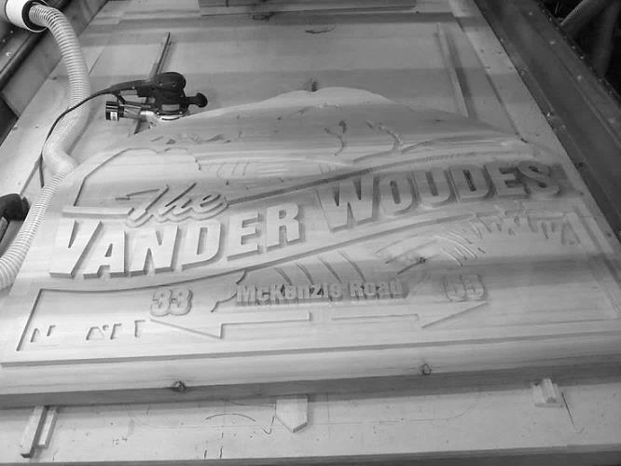

In this lab, we will be exploring the two major types of digital manufacturing: additive and subtractive manufacturing. Additive manufacturing is like pottery in that you keep adding clay to your sculpture until you have built the figure you are trying to create. We will be using a 3D printer, which acts like a computer-controlled hot glue gun, dispensing opaque plastic instead of glue. Starting at the bottom of your figure, it will build layer after layer of plastic until it finished building your object.

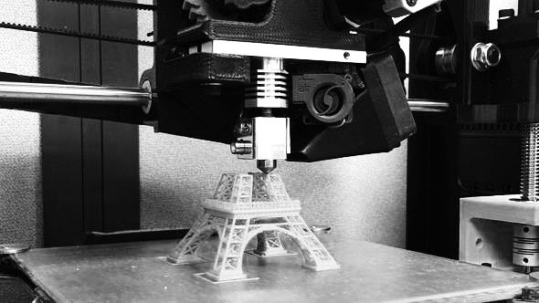

Subtractive manufacturing is like sculpting in marble. It involves starting with excess material and then removing material until only the desired object is left. Just as a marble sculptor chisels away at a large block of marble to create a figure, the computer numerical control (CNC) router removes wood from a large plank of wood to carve out a design. The Carvey’s (a CNC router) drill bit will follow the path you specify using the Easel software, allowing you to cut wood or similar materials in any pattern you can create on the computer.

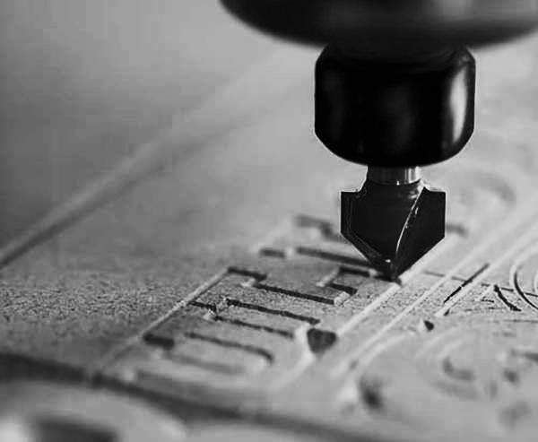

We will be using the Carvey to create the parts needed to assemble a working balsa wood model of the Wright’s Flyer II. This was the second successful powered manned aircraft built by the Wright Brothers in 1904. It was controlled by twisting the wing-box to alter airflow to control roll. The pilot would lie down on the wing and steer it using a series of levers. The Flyer II flew several miles and even made the first full circle flight in history.

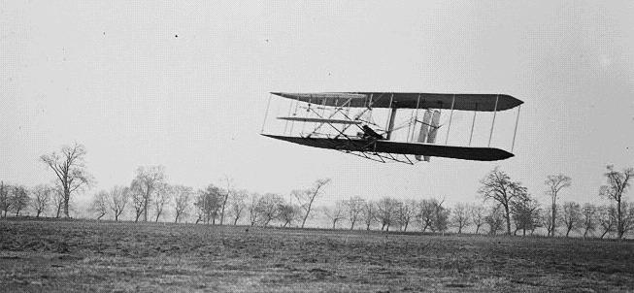

The design of this historical biplane has been modelled for our digital production and assembly, so that we can create and launch a model of this plane using a replica drop tower catapult. This launch device converts the gravitational potential energy of an elevated weight into kinetic energy to launch the plane. The drop tower itself was constructed of a derrick-style structure made out of wooden poles 20 feet in length. The tower would suspend a weight of 600 pounds about 20 feet off of the ground. A pulley allowed the weight’s vertical movement to be converted to a horizontal force, pulling the Flyer II along a horizontal 70 foot track. Once at the end of the track, the rope would wrap around the end of the track and then ultimately all the way back to the tower and connect to the launcher. As a result this launcher would have the weight pull the rope down the track and launch the Flyer II. Similar catapult launch systems are used on modern aircraft carriers since their decks are not long enough for a traditional runway takeoff.

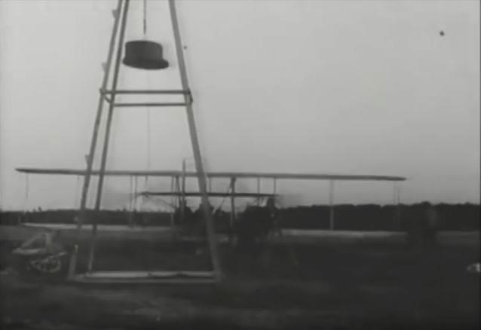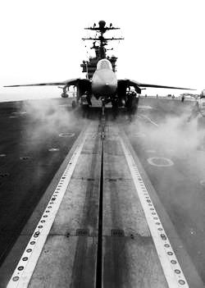

Laboratory Group 5c Overview and Instructions for Both Projects
Overview
- Additive manufacturing: Create a custom nameplate using Fusion 360 and then print it using the Mojo 3D Printer
- Subtractive manufacturing: Learn to use the Carvey with Easel software to carve parts of a Wright Flyer II model out of balsa wood
- Assemble and launch your model using a scale replica of the Wright Brother’s drop tower gravity launch system

3D Printing a Nameplate (Additive Manufacturing)

1. Opening Fusion and controlling your view
It's time to end your con-"Fusion" about 3D printing!

1-a. Open Autdesk Fusion 360 by clicking on its icon, or by doing a search for "Fusion" from the Start menu. There may be multiple applications in the Autdoesk suite installed on your computer. Click the one called Fusion 360.

b. A window should pop up. As you can see, there is an origin in the center and two axis (red and blue) in a plane.

c. Scroll to zoom in and out. Hold the middle button (scroll wheel) down while moving the mouse to move your view. Hold the middle button and the shift key down at the same time while moving your mouse to rotate your view. The view cube in the upper right corner of the screen can also be used to manipulate your view. Play around with these controls until you are comfortable using them.

2. Sketching a rectangle
Let's build some knowledge we can "draw" upon later!

2-a. In the next few steps, we are going to extrude a rectangle to create a rectangular prism base for our name plate. To do this, click the "2 Point Rectangle" button at the top above "Sketch."

b. You'll see three yellow planes appear in the middle. If you move your mouse near one, it will turn blue. Select any one of these planes to sketch in by clicking on it.

c. The view will rotate so you are looking top-down at the plane you are sketching in.

d. We are now ready to draw our rectangle. Click on the origin (where the colored lines) place the lower left corner of the rectangle.
e. Now, it is time to place the upper-right corner of the rectangle. Place it 20.0mm up and 100.0mm to the right of the origin to create a 20 by 100 rectangle.

f. Once, you click, your rectangle will fill with yellow, as shown below. Congratulations! You made a rectangle in Fusion.

3. Extruding the rectangle
Let's get a more "solid" grasp of how to use Fusion!

3-a. Now that you have accepted the sketch, it will turn orange and become a 3-D solid object. The extrusion tool takes a 2-D sketch and gives it a thickness. To extrude the rectangle, click on the "Extrusion" tool, which has the icon shown below. It can be found above "Create" in the toolbar.

b. Your view will rotate to a give you a better perspective.

c. We need to select the sketch we want to extrude. We want to extrude our rectangle, so select it by click once in the center of the rectangle (not on the edge). It will place an arrow in the direction of the extrusion and an "Extrude" dialog window will pop-up.

d. In the dialog window, ensure that the direction is "One Side" and the extent is "Distance." Then, type 2mm into the distance box (either the one in the dialog window or the one near your rectangle). Press enter or click "OK" to perform the extrusion. The object will turn into a 2mm thick rectangular base.

4. Add your name
Achieving "name" and fortune!

4-a. Now that we have our rectangular prism, we would like to carve letters into it (extrude them inward to remove material). To do this, click the "Create Sketch" button in the "Sketch" portion of the toolbar.

b. Your view will shift and the 3 yellow planes will appear.

c. This time, select the upper surface of the rectangular prism by clicking in the center of it. Make sure not to select a side surface or edge instead by accident. The view should shift to show that surface from a top-down perspective as seen below.

d. To add text, click on the word "Sketch" to bring up the sketch drop-down menu. Now, select "Text." Click in the center of your rectangle to place the text. A blue dot and an indication of the text's orientation will appear.

e. A window will also pop-up to allow you to enter your text. Enter your name and type in a reasonable height such as 10mm. Select the font "Franklin Gothic Heavy" (the same font used on the title of the classic movie Rocky) and make sure the angle is 0.0 deg. Click "OK." To bring up this window again, double click your text.

5. Orient and position your text
This is some "text" level shift!

5-a. Your text will appear in the rectangle. It may be upside down.

b. If it is upside-down, you can flip it by opening the text edit window by double-clicking on the text. Type "180" for the angle to rotate your text to be right-side-up. Click "OK" to close the pop-up window.

c. Now, we need to position the text. To do this, drag the lower-left corner of the text (there should be a dot to drag) to where you want it - you'll want to leave about 2-5mm of space around all edges. Also, be careful not to let it lock onto one of the edges (it may automatically do this if you place it very close to an edge).

d. Now, we want to increase its size. This can be done by dragging the upper right corner. Be careful not to rotate the text as you change its size - if you do rotate it, remember you can double click on it to bring up the edit text window that allows you to type in the angle you want. Also, if your name is too short or long to look nice, consider adding or removing your last name.

6. Extruding the text
"Hole"y smokes - we're almost done!

6-a. To extrude your text, click on the "Extrude" button (in the "Create" part of the toolbar)

b. Click the text you created to extrude it. Your view will rotate to give you a better view and pop-up window will appear labelled "Extrude"

c. You'll notice a blue arrow in the direction of the extrusion. We want to extrude the text into the base, so if you're blue arrow is facing up, set the extrusion distance to -2.0mm (in the extrude window). Make sure the direction is set to "One Side" and the extent is set to "Distance." The Operation should be "Cut." The preview will show the text extruding downward.

d. If your nameplate looks good, click "OK" to confirm the extrusion. Your name plate will now be one solid color with the name cut out.

e. Unfortunately, the nameplate is made of several objects, not just one (for example, the islands in the P, a and o of the nameplate above are separate objects. However, we want to select them all together. To do this, click and drag the mouse to create a selection. You'll want to start above and to the left of the entire object and drag down and to the right until the entire object is covered by the selection rectangle. The objects will turn blue to indicate that they are selected:

f. With the objects still blue, right click on them and select "Create Selection Set" from the list that pops-up. You may notice that a drop-down option appeared on the left side of the screen called "Selection Sets."

g. Click on the arrow to view what's under the "Selection Sets" header - you'll notice your selection set is there! (It may have a different name/number than mine):

7. Saving as STL file for printing
You'll have to "save" your excitement for a bit longer!

7-a. Now it is time to export your object in a format that can be 3-D printed. The mojo printer accepts .stl files, which are composed of a triangular mesh. To create an STL file, click on the "3D Print" button (in the "Make" section of the toolbar).

b. A menu will pop-up

c. Set the Refinement to "Medium" and uncheck the "Send to 3D Print Utility" checkbox. View the "Refinement Options" section by clicking on the triangle to its left. If "Surface Division" is set to 0, try selecting a different setting for Refinement and then changing it back to "Medium." That often fixes it.

d. Now, we are going to select the nameplate by clicking on the selection set we created (it’s under "Selection Sets" in the list/menu on the left." You'll know it's selected when the entire nameplate (including the little islands in the middle of letters like P,a, and o) are highlighted in blue.

e. If everything is in blue, click the "OK" button. A window will pop-up asking you where you want to save your file and what its name should be. Make sure the type is set to "STL Files (*.stl)" and type the name of the file. Click the "Save" button to save your STL file.

You are now done with the modeling portion of the tutorial. Now, it's time to print your nameplate on the Mojo 3-D printer!

8. Importing your object into Print Wizard
Let Print Wizard work a little magic for you!

8-a. On the computer adjacent to the Mojo 3-D Printer, open up the Print Wizard software by clicking on its icon

b. A window will pop-up asking you to find the file you would like to open. Select the .stl file that you had created in step 7. It will probably be in an undesirable orientation such as the one below

c. Click the "Orient Part" button and select the orientation that depicts the nameplate lying down on the plate with the text facing up (so that someone looking down at the nameplate from above could read the name). Make sure the text is not backwards! That is very important!

d. Enter 0.7 for the scale (on the left) and make sure the units are Millimeters (mm). Set copies to 1.

e. Change Supports to "SMART" (minimum) and change the "Part Interior" to "Sparse - Low Density" using the drop down menus. These settings are important, since the print will take a lot longer otherwise.

f. After examining your part in the center of the screen, click the "Print" button in the bottom-right corner.

g. A window should pop up showing confirming that the print has been sent and providing an estimate of how long the print will take and its material consumption. At 0.7 scale, it should take approximately 15 minutes. At full (1.0) scale, your nameplate would take about 30 min to print.

9. Printing the object
It's time to work your "mojo" on the Mojo!
9-a. The file has been sent to the Mojo printer and is in the queue, waiting to be released. So, now, it is time to get the printer ready for printing. Your Mojo 3-D printer should be turned on (as indicated by the green light, Mr. Gatsby).

b. Now, open the door in the front by gently pulling it down.

c. Remove the old build plate if it's in there (it is a piece of black plastic). Then, grab a fresh build plate and insert it into the printer. It slides in and down, then clicks into place as it's moved forward. Ensure that the two plastic containers on the sides that catch the excess plastic are not full.
Note: The Mojo's build plates are not intended to be reused. Thus, it is best to print as many items as you can per plate (a.k.a find some friends to make nameplates with!)

d. Close the door securely. The green indicator light will stop flashing and will turn solid green. You are now ready to print!

e. To begin the print, you'll need to open up the "Mojo Control Pane" application by clicking on its icon.

f. A window will pop-up showing the printer's supply levels and condition.

g. On the right side of the screen, you will see a preview of an object. Click on the drop-down menu below it to select your part. Once you have your part selected and see a preview of it in the frame in the upper right corner, confirm that there is sufficient model and support material by comparing the estimates with the remaining material levels (if it will be a close call, seek the advice of a professor or TA). Also, ensure that the print time is 10-20min per nameplate (print time is given in hours). For example, if you are printing 5 nameplates, it should take about 1-1.5hrs.

h. If everything is good, you are ready to go! Click the "Print" button near the bottom right corner. When the printing is finished, you will have your very own two-color plastic nameplates. Carefully peel the ivory support material off the plastic base to remove your nameplate from the black build plate. Your nameplate should sport two colors.

i. Congratulations! You just designed and printed yourself a two-color nameplate - from scratch using the Fusion 360 software package and the Mojo 3-D printer!

Carving Balsa Biplane Parts Using Carvey (Subtractive Manufacturing)
- Go online to easel.inventables.com/projects/AQ5wPg_VipF3M2ezUFQ5kg
- You should see a fuselage design for the biplane. Go to File Make a copy to duplicate this project for editing. If prompted to sign in, ask an instructor for assistance. Otherwise, a new project called “Copy of Fuselage” will appear in a new tab/window.
- On the left screen is the design to be carved and on the right is a preview of what it will look like. To practice using the Easel editor, click “Icons” on the top menu bar (there is a smile next to it). Select any icon. It will appear in the design window. Click on it, and practice changing its size, rotating it, and moving it around (these functions are all intuitive for those with Microsoft Word or Pages experience – if not, they may take a few moments to figure out).
- After you are comfortable moving around the icon you choose, look at the menu at the right side of the left screen. Under the “Cut” tab, slide the depth slider up and down to change the depth of the cut. If the depth is at the darkest value (at the bottom), all the wood in your icon (in black) will be removed. Otherwise, it will only remove layers of wood starting at the top.
- While it has been a faithful companion, the icon you chose must be removed before completing the rest of the tutorial. If your icon could talk – and we take this opportunity to remind you that it is just a picture on a computer – it would tell you to continue the tutorial without it, so please delete the icon by selecting it and pressing the Delete key.
- Now, use a ruler to measure the length and width of the balsa wood. If it is over 11 inches in either dimension, cut it down to 11 inches using a hobby knife on a cutting surface. Now, enter these dimensions in “X” and “Y” on the top right corner of the preview screen (the right side screen). The “X” dimension should be the larger dimension. The dashed outline in the design screen will change size to indicate where the wood is. Position (but do NOT resize) your fuselage so that it is in the center of the wood. Make sure that the fuselage does not intersect the red “L” in the bottom left corner, since that space represents the clearance needed for the mounting clamp and cannot be cut. Reposition your fuselage if needed.
- Now, measure the thickness of your wood with calipers. It should be ¼ inch thick. If this is not the case, you may be using the wood intended for the wings, which is thinner. Please find ¼ inch thick wood and re-measure the dimensions if needed.
- Now, enter 0.25 in. into “Z” on the top right. If you click on the fuselage, you may notice that its depth is now set to 0.25 inches. If that is not the case, please set it to 0.25 inches by dragging the depth slider all the way down.
- Set the material to “Soft maple” (top of right screen) and set the bit to 1/32.
- Grab a second piece of thick balsa wood the same dimensions as the wood you plan on using. This will be used as a base in case the Carvey cuts too deep – we don’t want to carve into the machine’s wooden surface. Place this base piece below the piece you intend to cut.
- Open the Carvey’s door by lifting it upward. Then, remove all clamps and screws from the Carvey’s surface, including the screws holding in the L-shaped mounting clamp. Slide your two piece wood-sandwich onto the bed of the Carvey and push it into the bottom left corner and screw the L-shaped clamp onto it using two green or blue screws (green is shorter, so if it doesn’t screw in tight, try using blue).
- Now, near the top right corner of the wood, find a screw hole in the bed and screw in a grey mounting clamp into it using the same color screw you used for the “L”-clamp. Use a metal staircase-like object (provided with the Carvey), orientated so that the staircase is as tall as possible (there are two ways to orient the staircase, only one of which is correct). Use the appropriate stair to support the notched end of the grey clamp. The beveled end should hold down the edge of the wood you plan on cutting. Be sure not to extend the clamp too far onto the surface of the wood since you do not want it interfering with the carving. Close the Carvey’s door.
- Now, click “Simulate” in the top-right corner. You will get a time estimate for the project as well as blue lines on the preview, showing the tool’s planned path. If the blue lines look like they are in the proper shape, you are ready to carve!
- Click “Carve” in the top-right corner to begin. The bit should be set to 1/32, as is already selected (if not, select 1/32).
- Now, carefully watch as the machine hones in to the “L”-clamp to calibrate. Don’t worry – it won’t cut the clamp! Keep a careful eye on it as it carves – if the wood becomes dislodged, makes unusual sounds, the bit touches a clamp, the bit breaks, or anything else goes wrong, immediately pause the carve by clicking on the blue-outlined button on the bottom right of the Carvey’s front (below the lip for the lid) and get an instructor’s attention. Please take a moment to locate that button now in case of emergency.
- After the piece is carved successfully, open the front of the Carvey and unscrew the clamps. Remove your piece. The fuselage will probably be attached to the wood surrounding it by a few tabs still. We’ll deal with these later. Set the wood aside. We are now going to cut the wings and supports.
- Go to http://easel.inventables.com/projects/FJqH1UE61NmJHt87gkyZWQ
- You should see a design of two wings, a small canard (front stabilizing wing) and two supports on a 5 by 11 piece of 1/1g-inch thick balsa. If you mistyped the link, try typing it again – there are two number 1s and two capital letter Js and no letter Is in the link.
- Go to File Make a copy to duplicate this project for editing like you did with the fuselage file. Now, grab a piece of 1/16 inch thick balsa wood and cut it down to exactly 11 inches. Measure its dimensions with a ruler.
Note: If the wood is not 5 inches wide or wider, you will need to carve the wings and supports on two separate blocks (they won’t fit on one). To do this, you’ll need to rearrange (not resize) the pieces, deleting a few pieces, carving, then undoing the deletion using the undo arrow. When moving pieces, you’ll need to select the whole piece by moving your pointer somewhere empty on the design window and holding the mouse’s button down while dragging to highlight the piece you want to move. If you accidentally move two pieces on top of each other, undo immediately to save yourself frustration.
- Now, measure the balsa wood’s thickness with calipers. It should be 1/16 of an inch thick. Enter this value for the depth of the wood on the right screen. Also enter the length and width of the wood. Note that the dashed line rectangle on the design screen (left screen) is the perimeter of your wood block. Make sure that the design is full contained within this rectangle. Make sure also that the design does not overlap with the red “L”-bracket clearance area. Set the wood to Soft Maple and the bit to 1/32 as before.
- Now, find a piece of thick balsa wood the same dimensions as the 1/16 inch balsa you plan on carving the design into. We will use this wood as a base in case the Carvey cuts too deep. As you did before, clamp both pieces of wood onto the board, with the 1/16 inch balsa on top of the other piece. You might need to use different colored clamp screws than before since this balsa wood is thinner. Remember not to extend the clamps too far onto the wood, since you don’t want to carve your design into the clamps! (Compare the design on the computer with the grid on the bed of the Carvey for an estimate of the clearance needed).
- Once it is clamped down and door is closed, click “Simulate” to confirm the toolpath and get a time estimate. Then, click “Carve…” Follow the on screen prompts and then begin carving.
- Watch the Carvey very carefully as it carves, remembering that the round blue-outlined button on the front of the Carvey in its bottom right corner is the emergency pause button. Press it immediately if anything abnormal occurs such as the bit touching a clamp, coming off/breaking, the wood coming loose, odd noises, etc.
- Once done, open the door and remove the piece from the Carvey. Unscrew your clamps completely and put all the pieces (except the “L”-clamp) back in the box. Now, grab the shop vacuum. Plug it in, and flip the switch. Vacuum the inside of the Carvey to remove all the sawdust. Also vacuum the table, Carvey door and anywhere else you see wood shavings. Then, turn off, unplug, and put away the vacuum.
- On a surface fit for cutting wood, use a hobby knife to carefully trace around the perimeters of all of the pieces (wings, stabilizer, supports, and fuselage). The goal is to cut through those tabs that were holding the wooden pieces in place as they were cut. After you have separated the pieces from their wood blocks, gently remove them – be careful, balsa is fragile! If needed, use sandpaper or the hobby knife to gently remove any remaining stubs on the perimeter of the pieces that the tabs left. Now, you are ready to assemble and fly your plane!

Assembling and Launching Your Wright Flyer II Model Using the Drop Tower
- Check that you have the 6-inch fuselage, 5-inch canard, two identical 8-inch wings, and two approx. 1.75-inch supports for the wings. All the parts except the fuselage should have been made from 1/16in thick balsa wood. The fuselage should be 1/4in thick.
- To start building the plane, examine the fuselage. The longer and more cambered (curved) of the two slits should be in the back of the plane, supporting the wings. The smaller slit is for the canard, which helps to stabilize the plane. Check that the curved slits are orientated concave down (like frowns, not smiles); then holding the fuselage in this orientation, gently slide in the canard with the flatter of the edges facing the front. The more curved side should face the body of the plane. If you are having trouble inserting the piece, try sanding it down a bit to help it fit better. If that doesn’t work, seek the advice of an instructor.
- Once the front canard has been inserted and is centered, take one of the two wings and insert it into the back slot with the flat edge facing the rear of the plane and the curved edge facing the body of the plane. Now, apply some wood glue to the holes and insert the tabbed ends of a support piece into one of the two holes. Repeat with the other hole. Support them while they dry by propping the plane up in a stable position.
- Once the wood glue has dried, orient the top wing with the flat edge facing the rear and the curved edge facing forward (just like the other wing) and glue it onto the tabs as before.
- After the glue has dried, add a push pin to the front tip of the fuselage such that the push pin faces forward (pushed into the plane, parallel to the ground). Then insert another push pin a small bit behind the canard. This one should be inserted into the fuselage such that the push pin is hanging below the plane.
- Now, examine the drop tower. Make sure the weights are in the bucket in the drop tower and the string goes around all four pulley wheels (top of tower, top of bucket, below track, and at the end of the track). Then, gently pull back the moving platform towards the drop tower until it gets locked in by the release mechanism (on the runway).
- To launch the plane, rest it atop the moving platform on the drop tower’s runway. The push pin below the plane should rest right in front of the mechanism and the fuselage should fit into the slit.
- Now, gently press down on the release mechanism and watch your plane take off!

