Modeling a Scanned Object with RapidWorks
RapidWorks allows you to use a scanned point cloud of an object from the NextEngine Desktop 3D Scanner to create a CAD representation of an object. This guide will walk you through the representation of a scanned apparatus from the 19th century that was used by Joseph Henry to demonstrate magnetic induction, often referred to as Ampere’s Apparatus.
When the object was first scanned, its features did not all come out clearly, which ended up requiring a relatively large amount of guesswork in the creation of the 3D model:
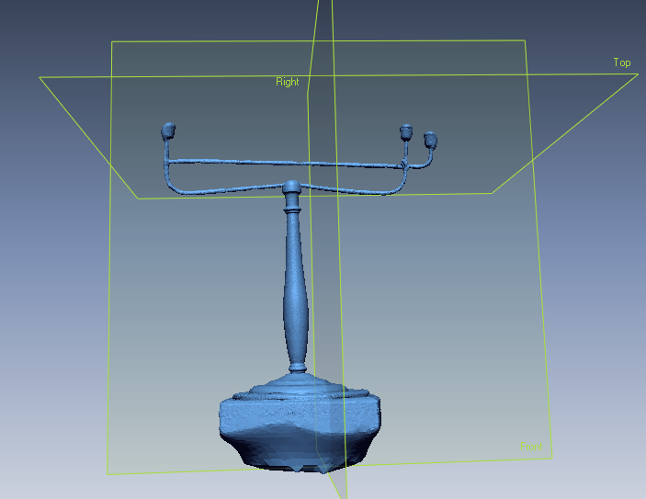
The first step taken was to trim the 3D-scanned base out of the point cloud, as it would not be a part of the model:
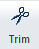
This button in the toolbar begins the trimming process.

After selecting the area to be removed and pressing the “Delete” key, the check button completes the action, leaving the rest of the object:
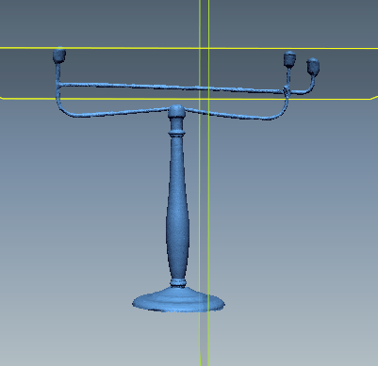
Next, the object was cleaned up to become simpler. This involved the commands “Fill Holes,” “Simplify,” and “Healing Wizard,” which are all underneath the “Polish” button on the toolbar.
For “Simplify,” make the Reduction Ratio 60%, then click the check mark:
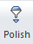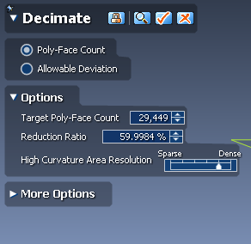
For “Healing Wizard,” check all the boxes, then click the check mark:
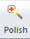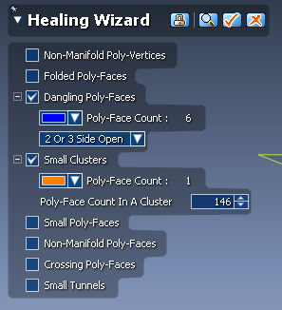
For “Fill Holes,” go to Select All – Poly-faces, click the “add bridge” button, then change the method to “curvature” to fill the holes:
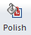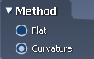

Next, the object will be separated into segments with the “Auto Segment” feature under “Segment” on the toolbar using the following settings:
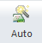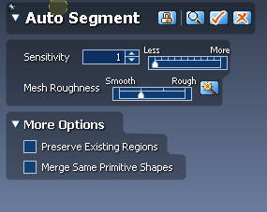

The final step before actually beginning the modeling process is the creation of a reference plane under the “Datum” section of the toolbar:
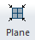 After pressing this button, select the segment that you wish the plane to be extracted from (in this case, it was the top section of the piece solely because it was clearly going to be the most difficult to model), then click the check mark.

Because of the symmetry and round features of this object, the ideal method of modelling was generally the creation of a 2D sketch of a feature, then a revolution of that sketch to create a solid. The 2D sketch command is underneath the “Sketch” section of the toolbar:
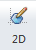 After initializing the command, select the new reference plane as the “Base Plane.”
Then, click the small eye button next to “Meshes” in the feature tree to leave only the reference lines created by RapidWorks visible:
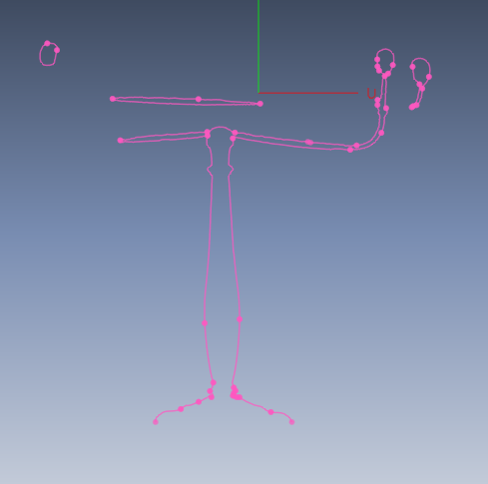
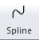 Select the “Spline” command and, piece by piece, begin drawing a section of the object using the reference lines: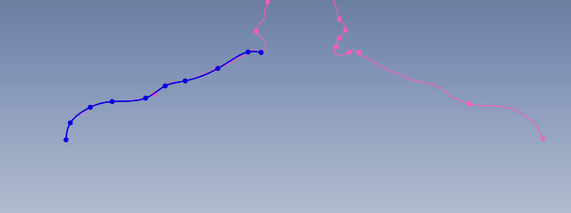
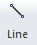 Because the sketch will be revolved, use the “Line” command to complete the sketch at the radius of symmetry of the object:
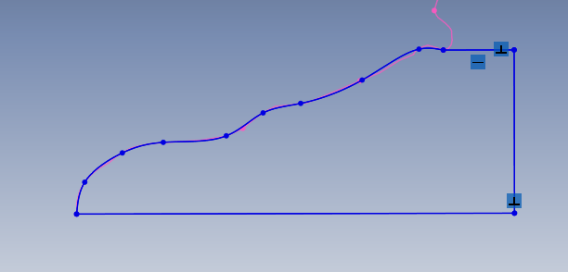

Next, the “Revolve” command under “Solidify” should be used to create the CAD representation of the part:
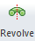
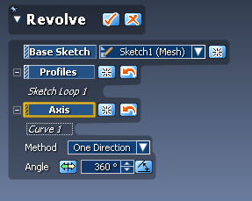
Select the new 2D sketch as the “Profile,” then the line of symmetry as the “Axis. Press the check and the object will be created.

Repeat this process for all of the applicable sections of the object:
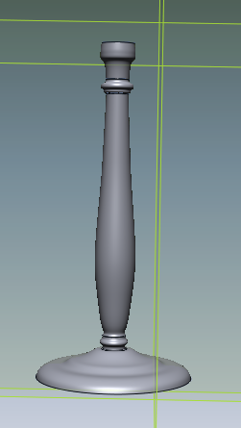

To create curved pipes and wires, the “Sweep” command under the “Solidify” section will be used.
First, go to Insert Ref. Geometry Polyline to create a Ref. Polyline. Select the feature that you wish to create and click the check mark to create the polyline. 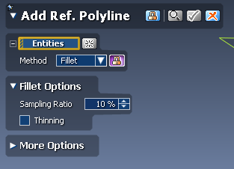
Next, click the 3D sketch button and draw the curve using the “Spline” command:
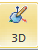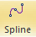
If necessary, edit the sketch under Tools 3D Sketch Tools Remove Constraint.
Next, create reference planes for the mesh sketch by going to Insert Ref. Geometry Plane. Change the “Method” to N Division and set the number as you wish (in this case, 4). Then, click the check mark:
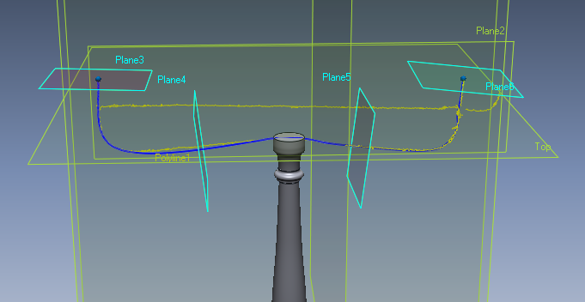
Click “Mesh Sketch” in the toolbar, then select a plane (in this case, 3). Then click the check mark and create a circle sketch on the polyline:
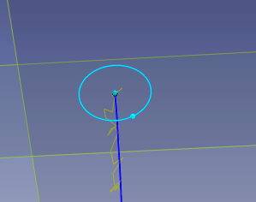
Finally, click the “Sweep” button in the toolbar:
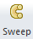 Select the circular sketch as the “Profile” and the 3D sketch as the “Path.” Then click the check mark to complete.
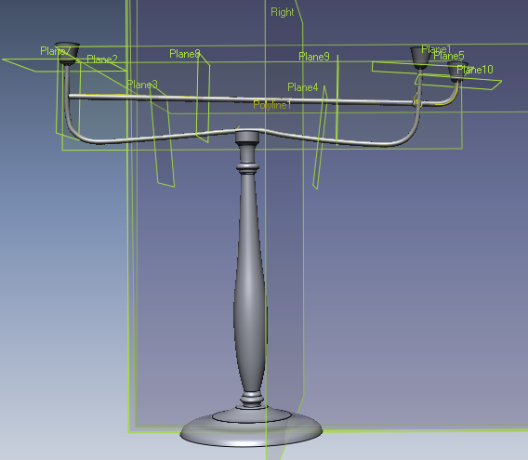
Using the skills shown, you should be able to completely model a three-dimensional object in RapidWorks using a point cloud from the NextEngine Desktop 3D Scanner. Then, it can be imported to SolidWorks using the following button under “Output” on the toolbar:
