Buckling Experiment Introduction
Materials can fail under very high tension or compression. For tension, the way materials fail is simply breaking across section. However, for compression, materials can fail by breaking across section or buckling. And usually in building or bridges, buckling comes first before breaking occurs. In engineering practice, design for buckling is important, especially for slender columns.
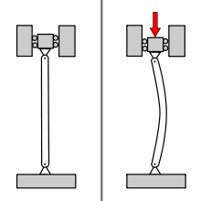
Figure 1 Buckling occurs by compressing the top
A well-known theory for buckling was made by Euler back in 1744. In his book of, Methodus inveniendi lineas curvas, he put down the Euler Buckling formula which he derived analytically:
$$P=\frac{π^{2}Ek}{L^{2}}$$
where L is the length of column and Ek is “absolute elasticity of the column”.
Figure 2 Leonhard Euler (1707-1783), Mathematician
It looks quite different from the Euler Buckling formula we know in modern day:
$$P=\frac{π^{2}EI}{L^{2}}$$
as we know E is Young’s Modulus (stiffness) and I is moment of inertia. EI together means stiffness against bending.

Euler was the first one who came up with the complete buckling formula. However, before Euler, Musschenbroek did the first experiment regarding buckling.
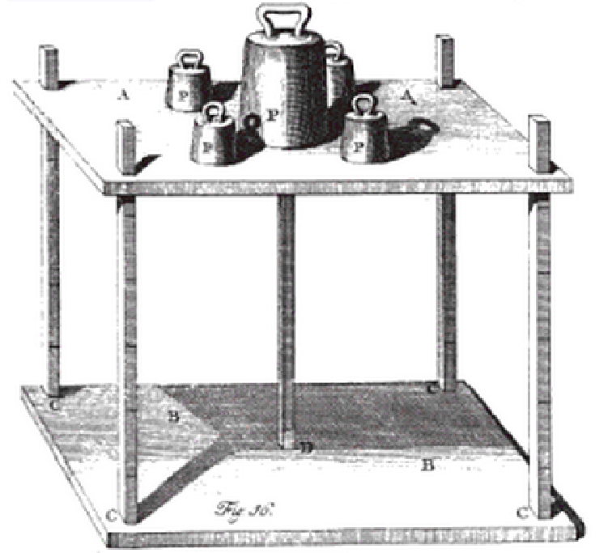
Figure 3 Musschenbroek's set up for buckling
In the experiment, the test specimen is placed in the middle. A sliding platform, guided by four columns at the corners, provides the loading to the specimen with the weights added above it.
However, what Musschenbroek found out was the buckling load is inversely proportional to the square of compression member length. He did not figure out the relationship between buckling load and stiffness of member.

