(456.) If an electric current traverse the thread of a right-handed helix, its front will be turned towards that end at which it enters; and if it traverse the thread of a left-handed helix, its back will be turned to that end at which it enters. CHAP. III. FLOATING HELIX- 45.5 Hence, when a current traverses * right-handed helix, the extremity at which it enter. has the magnetic properties of a south pole, and the extremity at which it leaves the helix has the properties of a north pole. When it traverses a left-handed helix, the extremity at which it enters has the properties of a north pole, and that at which it leaves the helix has the properties of a south pole.

(457) Such a helix was Fig. 217, arranged by Vanden Boss, so that, as the zinc and copper plates (fig. 217.) were immersed in acid water, the system should be suspended by a thread and free to move. In all cases it placed itself on the magnetic meridian.

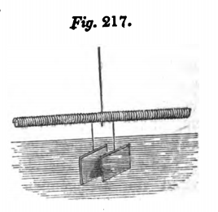

(458.) If a magnetic needle be placed with its poles in the axis of a helix through which an electric current passes, its north pole will be attracted towards the positive end of the current, and its south pole towards the negative end, when the helix is right handed; and its north pole will be attracted towards the negative end, and its south pole towards the positive end, when the helix is left-handed. If a magnetic needle, placed in the *of the axis of a helix, has its north pole presented towards the front of the current, its poles will be both equally attracted towards the centre of the axis of the helix, and the equilibrium of the needle will be instable. On the least disturbance of position, it will reverse the direction of its poles. If the south pole be presented towards the front of the current under like circumstances, both poles will be equally repelled from the centre of the helix, and the equilibrium of the needle will be stable. If the needle be placed any where in the axis of the helix, with its south pole directed before G G 4 456 ELECTRO-MAGNETISM, Book W. the current, it will move towards the centre of the helix, and will come to rest when its centre coincides with the centre of the helix. When the needle is sufficiently light, and the helical current sufficiently powerful, a curious effect may be observed if the needle be placed within the spires of the helix, so as to rest on the lower parts of the wire. The moment the connection is made with the battery, the needle will start up and place itself in the middle of the axis of the helix, where it will remain suspended in the air without any visible support.

